New England District Church of the Nazarene

New England Ministers’ News
Vol. 13, No. 8 December 2004

Thank you! Thank you!

Greetings my brothers and sisters in HIS HOLY NAME! I would like to thank everyone for joining in the Prayer Vigil on November 5, 2004. I know the effort that this prayer vigil took on the part of so many people! You all have blessed my life by being a part of a totally united front of saints! The cooperation between the churches was outstanding. The prayer covering was exceptional on the part of all of the missional areas! To God Be the Glory! Great things He has done and great things He plans to do! We must remain faithful!

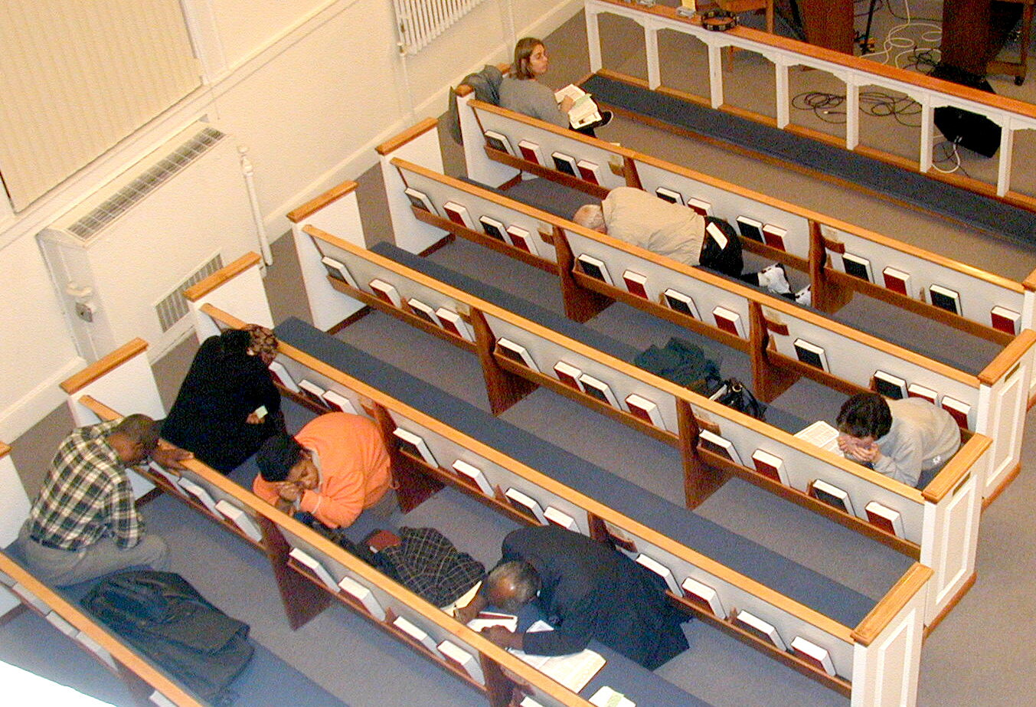
I believe with all my heart, soul, and mind that our Lord and Savior is pleased with us as a Body of Believers. Satan is not a happy camper! He wanted us to lose ground, but I know we took back some territory on November 5th. The Lord was with us every step of the way! He said that He would walk with us through every valley, desert, mountain, and fork in the road! Praise Him! Lift His Name on High!

I got goose bumps as I traveled from place to place hearing fellow Nazarenes calling out to our Heavenly Father to intercede on behalf of the needs of this district and the world. I was truly blessed when I ended up in our Rumford Church at 12:00 a.m. and heard a number of young people crying out to the Lord at that time of the night. Those young people could have been in a million other places, but they were in church, at the altar and around the church, calling out to our Lord and Savior. I felt blessed to be a part of this great effort! Know that Satan will try to steal, kill, and destroy (John 10:10) but we must remember who the Good Shepherd is and that HE will return one day to claim His sheep! We must remain confident with both holy boldness and faith believing in great and awesome miracles and blessings!

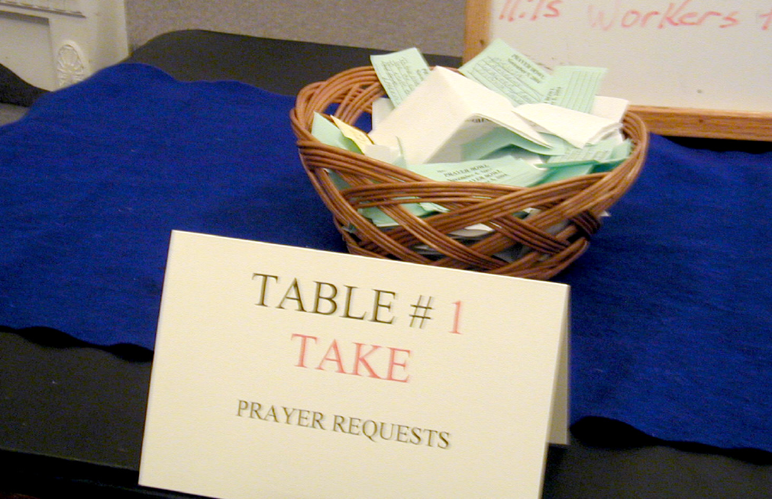
Keep and spread the faith!

Jossie

Dates to Remember!
Gathering of the Saints, January 29, 2005, 4:00-7:00 p.m.
NMI Convention, May 25-26, 2005*
District Assembly, May 26-28, 2005*

*Please be especially mindful of these dates so that there are no conflicts with your church schedules. ALL churches are to be actively involved in these critical district activities. (Last year several churches planned retreats during Convention and Assembly. Please make sure that church retreats and activities are NOT planned during these dates!)

Pastor/Spouses Retreat
Survey results will be posted on the website! Based on a brief look at the surveys, the majority of the folks had a great time! We had a great turn out! If you weren’t at Retreat, we missed you! Please plan to join us next year when we will once again be blessed by the fellowship, food, and great speakers!

Clergy Retreat
Plan to join us at our next Clergy Retreat on January 11-12, 2005. For more information, please call Dan Whitney at 603-428-8219 or 603-478-3363 or email him at danwhitney@whcamp.org.


Nazarene Youth International (NYI)
Coming in January is the return of the District Festival of Life, this is the preliminary event for the Regional Festival of Life in March (17-20). This will be a significant event for our students to have fellowship with students from all over the District and express their gifts in communication, music, athletics, etc.

For more information please contact Gerry Desrochers at 978-453-1063.

December 4 - Winter Quiz (Lori Jeffrey)
December 11 - District Council Meeting (Jeff Lane)
January 8 - Winter Quiz (Lori Jeffrey)
January 14-15 - FOL Districts (Gerry Desrochers)
January 21-23 - Junior High Retreat – Singing Hills (Lori Jeffrey)

Sunday School Ministries

American Bible Society Offering
December 12 is American Bible Society Sunday. Please join with our fellow Nazarene Sunday Schools from across the United States of America and receive an offering for this worthy cause. The offering should be sent to the General Treasurer. Our goal is for every Sunday School to send something.

Vacation Bible School
It is time to plan for Summer Vacation Bible School. Select a director. Pick a date. Order the brand new preview VBS packet from: www.vbs2005.com Try it—you will love it! It has a money back guarantee.

During an October tour of the Nazarene Publishing House, I (Ron Keller) got to see the exciting VBS materials being printed. WOW! They were the best I have ever seen. Kids and churches need VBS. How do I know? Well, VBS helped me as a child, it blessed my children, and it has helped grow the churches that I have pastored.

Word Action Sunday School Curriculum
Every Nazarene Sunday School should be using our doctrinally correct and easy to use Word Action curriculum. Every year it gets better and better—and it is always “holiness” from start to finish. Check it out and place your winter or spring order at: www.nazarenesundayschool.org or telephone 1(800)877-0700.

Sunday School Call-A-Thon
Recruit some volunteers. Assemble the telephone numbers of everyone on your Responsibility List and of persons who are not yet attending Sunday School. Use a Friday and Saturday, early in December, to invite everyone who does not attend to give Sunday School a try—And to thank everyone who attends for their faithfulness. Challenge them to bring a friend that Sunday.

The first week in January is also a prime time to conduct a Call-A-Thon. People will have made New Year’s resolutions and will be thinking about priorities. Sunday School is a convenient, proven effective, small group activity.

Children’s 2005 Camps Combined
Middler and Junior Camps will be combined for 2005. Watch for your promotional materials from our Windsor Hills Camp for the July 18 to 23, 2005 camp. Please pray about becoming a camp volunteer or about recruiting solid Christian volunteers. Change the date on your calendars.

Sunday School Information
For information about Sunday School, please contact Ron Keller, District Sunday School Chairman at (978)777-2060. For specific district activities you may contact the department and event leaders listed on pages 9 and 10 of the 2004 New England District Journal.

More very helpful information may be found at the Sunday School Web site: www.nazarenesundayschool.org or by contacting the Nazarene Publishing House at www.NPH.com or at 1(800)877-0700.

To see the Attendance Statistics for the month of September go to the district website: www.newenglanddistrictnaz.org. Please remember to submit your attendance statistics to Ron Keller or Dan Beckwith every month!


Nazarene Missions International

December Challenge - Nazarene Compassionate Ministries
When we give to Compassionate Ministries we are not only helping the needy but God is also using NCM to reach the world for himself. Some facts you should know…
- In the last decade the Church of the Nazarene has entered 22 countries through Nazarene Compassionate Ministries.
- A new Nazarene church is started every 12 days through disaster response efforts.
- If you have food in the refrigerator, clothes on your back, a roof overhead, and a place to sleep…you are richer than 75 percent of the world.

Because of the recent hurricanes, the Crisis Care Kits (CCKs) supply has been depleted. CCKs are desperately needed! We ask for your help by…
- Filling one or more banana boxes full of Crisis Care Kits. (One box holds six kits.)
- Sharing your used clothing (in good condition) with others. Follow directions carefully. Our missionaries can be fined if you put items in the boxes other than what is supposed to be there.
- Sponsoring a child, giving an offering to Compassionate Ministries, or giving to “Books for Pastors – Tools for Ministry.”

Your church’s sacrifice will be greatly appreciated.

January
District Missions Expense Allocation is due on January 1. Make your check out to “N.E. District NMI”, mark it DMEA. Include your church name and send to Lucy Bollinger, 141 Green View Drive, Loudon, NH 03307. (Note address change.) We thank you for your support of the DMEA. A report will be put in a future “Messenger.”

The Million Hours of Prayer (MHP) for the General Conventions and Assembly begins in January and goes through June 2005. Every Nazarene is challenged to pray for a minimum of two hours during this time. The times of prayer can take place individually, in small groups, or in corporate worship settings. Remember our District Conventions and Assembly, May 25-28, 2005, when you pray.

Did You Know?
- January is Nazarenes In Volunteer Service month. For information go online to www.nazarenemissions.org. Click on “Involvement” and go to Volunteer Ministries.

- February is Alabaster Month

- February 27-March 5 is Nazarene World Week of Prayer. The District Prayer Brunch will be held March 5 at Lowell Church of the Nazarene. This Brunch will close out the week. Cinda Kammermann, missionary to Russia, will be the speaker.

- The following missionaries will be doing deputation tours on our district … February 2-16, 2005: Dan & Melody Anderson, Uganda, and February 26-March 6, 2005: Cinda Kammermann, Russia. We still have open dates. Contact Carol Fogle, Deputation Secretary, via e-mail: holdinat26@yahoo.com or call 508-428-9751 to schedule.

- Please pray for the new world Mission Broadcast program that began on November 1 in the Middle East. Pray that Foshat Amal (Journey of Hope) program will give hope to listeners in this war-torn, volatile area of the world.

Reynolds Winter Courses
The Practice of Christian Ministry (PAS-2013) will be taught by Dan Whitney at Windsor Hills Camp on Dec. 3-4, Jan. 8-9, and Feb. 11-12.

History and Polity of the Church of the Nazarene (PAS-2023) will be taught by Larry Ogden at Lowell First Church on Tuesday evenings at 6 p.m. from Dec. 7 through Feb. 15.

History and Polity of the Church of the Nazarene (PAS-2023) is also being taught in the French language by Pierre Louis Zephir.

Please contact Rev. Bruce Paul for more information at 781-585-3419.

Share Your Ideas
Have you just had a Thanksgiving Service that was especially meaningful? Have you tried something new with small groups that is working? Beginning with the next issue of the New England Ministers’ News, you’ll have an opportunity to share your ideas on a variety of topics with other pastors on the district. When there’s room, we’ll publish some of the responses in the paper version of the NEMN - but we’ll attempt to publish all responses in the on-line version.

Topic for January 2005: What happens at your mid-week service? When do you meet? Send responses to: bandrew@110.net. All responses must include the church and your name. Type “Share Your Ideas” in the subject line.

Save this Date!

January 29th 2005

All Saints Gathering

Wollaston Church of the Nazarene
4:00- 7:00 p.m.

Prayer Requests
James 5:13-14
- We need to pray ...
- for Chuck and Sally Zink and their cancer treatments.
- for David Wooster who needs a heart transplant.
- for our students at ENC.
- for all our public schools and students.
- for all of our churches!
- for our public officials both local and national.
- for unity in the Body of Jesus Christ!
- that the Anointing of the Holy Spirit fall fresh in every service!
- for the sick and hurting in all of our churches and homes!
- for new people to be won for Jesus Christ!
- that God will use each of us everyday as an instrument of HIS Love to others!
- that HE will increase our Faith in HIM!

Praises!!!
- We praise HIM for waking us up this morning!
- We praise HIM for sending HIS SON!
- We praise HIM for providing for our tables and shelter for our comfort.
- We praise HIM for HIS love.
- We praise HIM for sending the HOLY SPIRIT!

Let our prayer be: “Thy Will Be Done!”

New England District Calendar

NOVEMBER - NMI Emphasis: Thanksgiving Offering, World Evangelism Fund & Prayer

18 District Advisory Board – Quincy
25 HAPPY THANKSGIVING !

DECEMBER - NMI Emphasis - Compassionate Ministries & Prayer

1 Crisis Care Kits due
3 District Ministerial Credentials Committee
4 District Teen Quiz
11 District Finance Committee
12 District Ministerial Credentials - Nashua
23-31 District Office closed
25 MERRY CHRISTMAS!

JANUARY - 2005
NMI Emphasis: Volunteer Ministries & Prayer

1 District NMI Allocation due
8 SSM Board -
8 District Teen Quiz
11-12 Clergy Retreat
13 District Advisory Board - Quincy
14-15 District SSM, NMI, NYI Team Planning
18 Mission Directors – Nashua
18 WHC Board – Nashua
21-23 SNOWBOUND - Junior High Retreat
22 District Nominating Committee – Nashua
29 District-wide Church Gathering of the Saints – Wollaston Church

New England District Church of the Nazarene
PO Box 690513, Quincy, MA 02170-0513
Phone: 617-786-9496, Fax: 617-786-9574
E-mail: nedoffice@cs.com
Jossie Owens
District Superintendent
Gary W. Jones
Assistant District Superintendent

To view New England Ministers’ News online,
go to the New England District website:
www.newenglanddistrictnaz.org.

