New England District Church of the Nazarene

New England Ministers’ News
Vol. 15, No. 7 July 2006

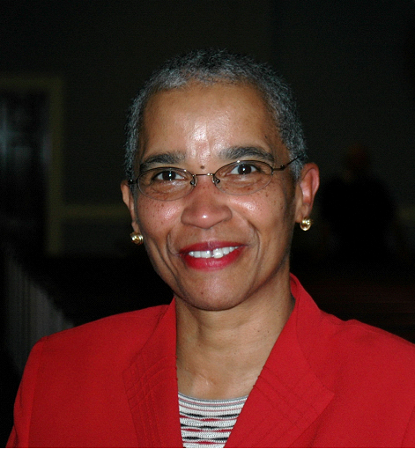

“His Presence at District Assembly”

Hosea 6: 2-3

Greetings in His Precious Name! If you attended District Assembly, I know that you are still under the blessings of His Anointing! If you did not attend, you missed His Presence in a special, special way! The music was anointed, the Word was anointed, and the reports from all of the areas were anointed. I am still thanking God for answering prayer regarding District Assembly! Hosea 6: 2-3 captures some of my sense of what took place at assembly.

After two days he will revive us. The Lord came amongst us and revived us again! The Baptismal Service was anointed. The testimonies of the saints were real, true, and blessed!
On third day he will restore us. The Lord came and restored many people unto Himself again! To God be the glory!
It says in that scripture that we may live in His presence.

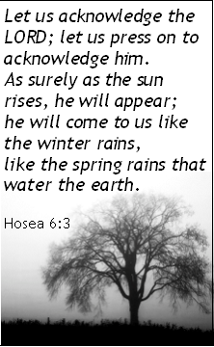
We must acknowledge Him and then, He will come to us. He came my sisters and brothers to us like the winter rains and the spring rains! If we seek Him, He will be found! It was great worshiping with so many saints in one place! Can you imagine what it will be like when we all come together as one Body in Christ on that great Day of the Lord!

Blessings in His Holy Name!

Jossie



Sunday School
Ministries

Ron Keller, District Sunday School
Ministries Chairperson

July 17 to 22 Children’s Camp
If the children in your church are not yet registered for Children’s Camp, run (do not walk) to your computer and download camp applications from our Windsor Hill’s website: www.whcamp.org . Get the applications and forms filled out and sent in ASAP! Space is limited and time is running out! This year’s camp will be sold out.

Rick Smith, our very capable Children’s Camp Director, and his staff have planned to make this camp the best ever. Dan Couch and family (that includes the “goofy” puppets) will be on hand to lead the morning and evening chapel services.

Questions? Telephone Rick at (802) 723-4824. Please pray that God will bless and honor the hard work that has gone and will go into this year’s camp.

Disciple Children and Teens
Many children and teens will attend and enjoy our summer camps at Windsor Hills Camp. Many of those who attend will make a first time commitment to Jesus Christ during the camps. Others will recommit their lives to the Lord.

After the spiritual uplift of camp, it is back home, to family and friends. Back to the same environment where they lived without living in true commitment to, and relationship with, Jesus. Many may be the only committed Christian in their homes and schools. Will they return to the old lifestyles? Will they be able to lead their friends to Jesus or will their friends be successful in temping them to re-embrace the old and sinful ways? Will they remain on the “narrow way” that leads to Heaven?

We can help them to lead transformed lifestyles. How? Have them give a public testimony of what happened to them at camp. Don’t wait until later. Give them opportunity to make a prompt, public and local confession of Christ. Exhort your congregation to pray for and encourage these young Christians.

Explain to them the necessity of reading and studying the Bible, daily. Give them age-appropriate, Bible based literature to read. Teach them how to pray. Find some age-appropriate, contemporary Christian music and videos to replace some of the secular stuff that pulls away from Christ, tears down morals and wages war against the peace that they experienced in relationship with Christ and with other Christians while at camp.

We can also explain to their Sunday School teachers the importance of good lesson preparation. Our youth need interesting and attractive holiness materials to help them in spiritual formation. Encourage your teachers to pray for and with these young people. A teacher must realize that their love, interest, listening ear, smile, patience and preparation (or lack of preparation) will have a great influence in shaping the spiritual lives of their students. Teachers, pastors and church members must be good stewards of the youth that God has placed in our trust.

Our churches and camps have planted the seed, watered it and given opportunity to expose these youth to the truth. God gave the increase and changed their hearts. Now it is up to us to work with God to help them to grow in Christ and to bear fruit.

Prime Time
Senior citizens are welcome to enjoy a special Prime Time Day at Family Camp. Richard and Louise Clifford, (508) 295-2580, have planned this event for Thursday, July 6 at Windsor Hills Camp. Make it a day. Enjoy the morning Bible Study Hour, eat lunch and dinner with other well seasoned friends and then plan to sing in the Senior Adult Choir during the evening service.

Zone Chairpersons
All pastors and Sunday School superintendents have been contacted by their Sunday School Ministries Zone Chairpersons. Each church can make our Chairperson’s job easier by a prompt telephone call or e-mail to our Zone Chairperson on the last Sunday of each month. Please report the Sunday School and Morning Worship average attendance and the total enrollment. For more information, please telephone our District Chairman Ron Keller at (978) 777-2060.

Children’s Fun Day
The annual District Children’s Fun Day has been well planned and awaits our children’s enjoyment. All churches have received posters for this popular Saturday, August 12, event. Every church is invited to enjoy the day on the grounds of the Wollaston, MA church. Please telephone District Bible Quiz Director Patsy Malas at (617) 770-1946 for information.


Nazarene
Youth
International

Rick Gardner, District
NYI President

One Body, One Faith, One Mission
I want to start by saying thank you to all who have given me this opportunity to serve as your new District NYI president. I have served on the council for a few years now and I along with the council have noticed an unfortunate decline in the participation and attendance to our District NYI functions. I began to ask myself what has happened to the fire and the unity that once burned in our local churches for District youth activities? As I have pondered this, I am reminded of what Stephen Macchia wrote in his book, Becoming a Healthy Church, “independence needs to be broken.” He also said, “One of the greatest sins of the Christian church today is an independent spirit. We’ll do it our way or no way.” This quote led me into thinking about how many churches on our District have taken this type of attitude towards our District NYI gatherings such as camps, retreats, the Mt. Climb, NYI Convention, etc.

Although I believe it is very important for each local church to have their own activities, I do feel that they have forgotten that they are also a vital part of the District NYI team. Some may say, “If we are able to have our own mission trips and retreats, then why do we need the District NYI?” This question has been on my mind for some time now and I believe the answer is, “A local church cannot fulfill its true calling without the District NYI, Sunday School Ministries, NMI, and ENC. The reason for this is simple; just as the local church serves as the body of Christ, so too does the New England District. And everyone must do their part in order for the mission of the District to fulfill its calling of spreading the Gospel. We are all one body, one faith, one hope, and on one mission.

It is my goal as your District NYI president to partner with each church, so that we can begin to work together in order to disciple our youth groups and start reproducing healthy Christians who will in turn carry the Church of the Nazarene today and into the future. This is exactly what Paul meant when he wrote, “It was he who gave some to be apostles, some to be prophets, some to be evangelists, and some to be pastors and teachers, to prepare God's people for works of service, so that the body of Christ may be built up until we all reach unity in the faith and in the knowledge of the Son of God and become mature, attaining to the whole measure of the fullness of Christ. Then we will no longer be infants, tossed back and forth by the waves, and blown here and there by every wind of teaching and by the cunning and craftiness of men in their deceitful scheming. Instead, speaking the truth in love, we will in all things grow up into him who is the Head, that is, Christ. From him the whole body, joined and held together by every supporting ligament, grows and builds itself up in love, as each part does its work” (Eph 4:11-16). It is my prayer that we begin to work together as one in the body of Christ.

NED Youth Website
Pastors, please encourage your youth pastor or leader to check us out on the District website at www.nednaz.org and click on “youth” for camp registration forms, which are coming up soon. They can also find information concerning the Mt. Climb, NYC 2007, quizzing, and much more.

In His Grip,

Rev. Rick Gardner
NED NYI District President
pastorrickgardner@msn.com
781-593-5742

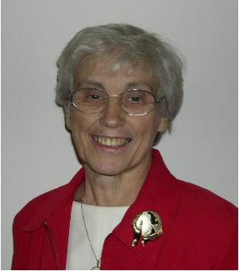
Nazarene
Missions
International

Gerry Perry, District Missions President

Scripture for the Month: “And do not forget to do good and to share with others, for with such sacrifices God is pleased.” (Hebrews 13:15, NIV)

World Evangelism Fund
We deeply appreciate those who pledged to help meet the goal of 90% for World Evangelism Fund. Please send in your checks to Rick Smith, District Treasurer, or send to the General Treasurer in Kansas City. Make sure you indicate your church and the year 2005-2006. We need your prayers and sacrifice to meet our commitment to World Mission. Please let Dr. Owens or Gerry Perry know if you did not get to pledge and are willing to do so.
This fund supports 801 missionaries, outreach ministry in 151 world areas, retired missionaries, theological colleges, seminaries and training schools, 2 hospitals, literature in 95 languages, facilitation of NCM, W & W and WMB, and administrative costs to facilitate ministries and services in churches worldwide. In other words your support provides funds for the best delivery system of any mission organization.

District Requests
- Pray for the leaders of the summer camping program.
- Pray for David & Rhoda Restrick, missionaries-in-residence, during the Children’s and Senior High Camp at Windsor Hills.
- Pray for the missionaries-in-residence at Junior High Camp, coming to us from a Creative Access area.
- Pray for the TESS mission trip to the Gulf Coast and the Work and Witness trip to Russia in July.

July Emphasis is International Ministry, Bible Schools and Seminaries. Pray for International Ministries. Books for Pastors – Tools for Ministry continues through September 2006 this year and is the Children’s Project again.

August is LINKS Month … This is a great time to send a greeting to your new LINKS missionaries. See page 31 in the District NMI Handbook for your LINKS assignment and your adopted missionary family.

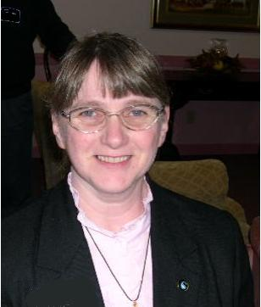
Chaplaincy
Ministries

Sally Miller,
District Chaplaincy
Director

Please pray for our Chaplains. Chaplains face the unknown with people that are unknown to them. Most of the time Chaplains are ministering to people they have never met until they meet them in a time of sorrow or trouble. Chaplains must rely on the Lord. We train to help people in crisis, but we are constantly surprised by what the day brings. We are faced with helping people who are injured or sick and those who have lost someone to death. People react in many ways when they are faced with trouble. When told that a loved one is dead I have seen family members act out in many ways. This is especially true if the person died suddenly because of accident or murder. Some family members scream when they are told, some pound the wall or drop to the floor and pound the floor. Some people just cry, but all need the peace that God brings through the Chaplain. So keep us in your prayers.

Rev. Sally Miller
District Chaplaincy Director

DISTRICT NEWS
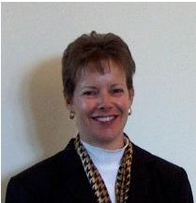
Reynolds Institute Announces Fall Courses
Lisa Morrison, Director of Education, announces that the following courses will be available for the Fall 2006 Semester:

New Testament Gospels (BIB 2033)
Instructor: Rob Fringer
Intro. to Christian Education (CE 200)
Instructor: Doug Milne
Intro to Christian Ministry (PM 100)
Instructor: Lisa Morrison

For more information or to register for a course, go to: www.reynoldsinstitute.org.

Mission Strategy Coordinator
District "Mission Strategy Coordinator" Kim Richardson has begun his "Listening Tour" with pastors. Any pastor desiring to get together is encouraged to contact him. Kim is also available for Faith Promise Weekends, worship services or workshops.

Preston, CT Installs New Pastor
Rev. David and Tonya Lafevor were installed Sunday, June 11th as the new pastors of the Preston, Connecticut Church of the Nazarene. David is a naval officer stationed in Connecticut and was a long-time Nazarene growing up in Michigan. He and Tonya have three lovely children.

Churches in Pastoral Transition
Keep the following churches in prayer as they search for new pastors:
Brockton, MA First
Burlington-Williston, Vermont
Lowell, MA First
Providence, Rhode Island First
Quincy, Mass. Bethel
Quincy, Mass. Chinese

Congratulations!
* ENC’s New England District Pastor of the Year: Rev. Ken Stanford, South Weymouth
* NBC’s New England District Alumna of the Year: Rev. Michael Chambers, Hooksett, NH

New England District Calendar

JULY 2006

NMI Emphasis: International Ministry, Bible Schools & Seminaries, and Prayer

1-9 Family Camp
6 Prime Time Day - WHC
9-15 Encounter (Teens) to Gulf Coast
8 WHC Board - WHC
11 District Dept. Heads - NED office
District Advisory Board – Quincy
Children’s Camp
19-31 Work and Witness Trip to Russia
24-29 Senior High Camp

Prayer Requests

Pray that the church will have an major impact for the kingdom of God by ministering to those who have lost so much during the recent flooding.
Pray for our cities and the rise in violence.
Pray for our young people’s protection from violence and the evil one.
Pray for the victims of the hurricanes.
Pray for the churches which were damaged.
Pray for our schools, our teachers, children, parents
Pray for our open churches.
Pray for the sick.
Pray for the lost.
Pray for the persecuted church.
Pray for revival in the district.
Pray for revival in every church.
Pray for our President and his family
Pray for all of our government officials.
Pray for the courts.
Pray for marriages.
Pray for the college.
Pray for our region and our generals.
Thank HIM for every opportunity to serve!

New England District Church of the Nazarene
PO Box 690513, Quincy, MA 02170-0513
Phone: 617-786-9496, Fax: 617-786-9574
E-mail: nedoffice@cs.com
Jossie Owens
District Superintendent
Vincent Crouse
Assistant District Superintendent

To view New England Ministers’ News online,
go to the New England District website:
www.nednaz.org.

One in Heart and Mind
Bible Reading for
July 2006

One in Heart and Mind
Bible Reading for
January 2006
The Bible Reading Schedule is from the “Year of the Bible” website. You may also read the daily reading on line at: http://yob.gospelcom.net/reading.php

1 1 Thes. 4:1-18
2 1 Thes. 5:1-28
3 2 Thes. 1:1-2:8
4 2 Thes. 2:9-3:18
5 1 Cor. 1:1-25
6 1 Cor. 1:26-2:16
7 1 Cor. 3
8 1 Cor. 4
9 1 Cor. 5
10 1 Cor. 6
11 1 Cor. 7:1-24
12 1 Cor. 7:25-40
13 1 Cor. 8
14 1 Cor. 9
15 1 Cor. 10:1-22
16 1 Cor.10:23-11:16
17 1 Cor.11:17-34
18 1 Cor. 12
19 1 Cor. 12:28-13:13
20 1 Cor. 14:1-25
21 1 Cor. 14:26-15:11
22 1 Cor. 15:12-34
23 1 Cor. 15:35-58
24 1 Cor. 16:1-24
25 2 Cor. 1
26 2 Cor. 2
27 2 Cor. 3
28 2 Cor. 4
29 2 Cor. 5
30 2 Cor. 6
31 2 Cor. 7

The Bible Reading Schedule is from the “Year of the Bible” website. You may also read the daily reading on line at: http://yob.gospelcom.net/reading.php

