New England District Church of the Nazarene

New England Ministers’ News
Vol. 15, No. 5 May 2006

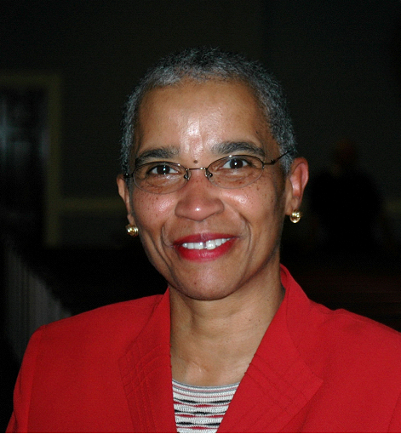
Exciting Assembly Services
and Events!
Come … Bless ... And Be Blessed!
May 25-27

Thursday Evening – Celebration What God Has Been Doing
Friday Noon – Celebration of Our Fellowship with
an Assembly Picnic for All
Friday Evening, 7 p.m. – Celebration of Baptism & Music
Friday Late Night – Celebration Concert and Reports
Saturday Morning – Celebration of Ordination with a Noontime Reception for our Ordinands

Please be in prayer … that the Holy Spirit would preside over every meeting and event … and over our General Superintendent and District Superintendent and all those making preparations
for this great gathering of God’s people.

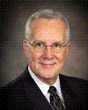
Dr. Jesse C. Middendorf is a general superintendent in the Church of the Nazarene with an office at the International Center of the denomination in Kansas City, Missouri.
He was chosen for the highest elected office in the church at the 25th General Assembly at Indianapolis, Indiana, in June 2001, after serving for ten years as senior pastor of First Church of the Nazarene of Kansas City, Missouri.
Dr. Jesse Middendorf was born in Nashville, Tennessee. He has been preaching since age 16, was first district licensed while a student at Trevecca Nazarene College (now University) on the Tennessee District, and ordained an elder in the Church of the Nazarene in 1969 on that district. He received his bachelor of arts degree from Trevecca Nazarene University in 1965 and his master of divinity degree from Nazarene Theological Seminary in 1968. In 1989 Southern Nazarene University conferred upon him the doctor of divinity degree. He earned a doctor of ministry degree from Nazarene Theological Seminary in 1999.
He has pastored Nazarene churches in Clarksville, Tennessee; Ashland, Kentucky; Albuquerque, New Mexico; Richardson, Texas; and Kansas City, Missouri. During the years 1985-1991 he was superintendent of the Northwest Oklahoma District Church of the Nazarene.
He has written numerous articles for various religious periodicals, has authored chapters in several books, and is author/editor of The Handbook of Christian Ritual published in 1997.
Dr. Middendorf’s hobbies include playing golf and flying single-engine aircraft. He and his wife, Susan (nee Marlowe), have three children: Jon, Marlo, and Jim; and four grandchildren.



Sunday School
Ministries

Ron Keller, District Sunday School
Ministries Chairperson

Children’s Camp
July 17 through 22 will find our Windsor Hills Camp filled with boys and girls getting acquainted with and getting excited about Jesus. For most children, summer camps are positive life changing experiences. For six days they are immersed in a joyful Christian atmosphere and the Holy Spirit uses that time to share his voice with their young minds.

Last year, the morning and evening chapel services were exhilarating. With joy, the children sang songs about Jesus. They were quick to volunteer their participation in the conduct of those worship services. When Chaplain Dan Couch taught and preached the Word of God they listened intently. Many made the important decision of inviting Jesus Christ to become their Personal Savior. Those who were already born again saw their faith strengthened as they interacted with other born again from above children and staff members who loved them for Jesus.

To make sure the children from your churches and Sunday School will be able to attend this year’s camp you will need to tell their parents and the children about the week that can change their lives. Pictures, posters, registration forms, telephone numbers and more are available at the WHC Web-site www.whcamp.org.

Many churches have begun scholarship funds to help families afford the week’s tuition. Those whose registration is postmarked by May 1 will have their tuition discounted by $30.00. Registrations by June 1 will save $20.00 and by July 3 will save $10.00. Those who register after these dates will pay the full price of $255.00. After July 10, please do not send applications until you telephone Registrar Fern Woodruff. Each year the Sunday School Ministries Board, working with the local churches and parents, makes some partial scholarship aid available. For scholarship information contact Ron Keller at (978) 777-2060. The week will be sold out. So, urge each family to submit their registrations early.

Director Rick Smith has announced that the Dan Couch family will return this year to lead the children in worship. Games, crafts, swimming, boating, archery and many other child-oriented events will fill the days. For specific program information contact Rick at (802) 723-4824. Campers must be between the ages of 8 and 12 and be entering third through sixth grades.

Children’s Camp Staff
Male and female counselors and adult staff volunteers are always needed to shepherd the children through their week at camp. Those who apply must be spiritually mature and have the gifts and graces necessary to work with children. New Hampshire law requires all staff members to undergo a criminal records check.

A limited number of “Counselor in Training” positions are available for mature teens. They will be trained by counselors and camp staff to become future camp counselors. Applications are available on the WHC website. Register early, because there are always more teen applicants than positions available.

VBS
“First Action Heroes” Vacation Bible School materials are available from our Nazarene Publishing House at www.nph.com or by telephoning (800) 877-0700. I, Ron, have examined these new VBS tools and they are colorful, well written and easy to use. A complete sample kit is available for only $64.99 and comes with a money back guarantee. VBS strengthens the faith of children and opens the church door to children from non-churched homes.

NED SSM Dates
Prime Time Day at WHC—July 6.
Children’s Fun Day—August 12 @ Wollaston.
NED SSM Board Meeting-September 9 @ Danvers.
Men’s Retreat at WHC—September 15-17.
Women’s Retreat at WHC—October 6-8.
Equipping Day and SSM Convention—November 4.
March 4, 2007—NED SSM Board Meeting @ Wollaston.
July 16-21, 2007—NED Children’s Camp.

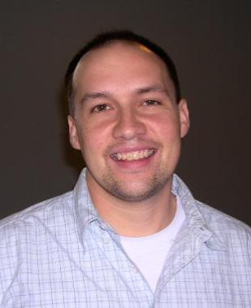
Nazarene
Youth
International
Jeff Lane, District
NYI President

The summer is right in front of us-- so here are a few key events for you to consider for local NYI.
Junior High and Senior High Camps are only two months away. This is your opportunity to take your local student ministry and join over a hundred 7th-9th graders or 10th-12th graders from all over New England as we gather for a week of challenging speakers, engaging praise and worship and encouraging relationships at our own district's Windsor Hills Camp ( www.whcamp.org) in beautiful central New Hampshire. For more information or downloadable forms you can go to www.whcamp.org or www.nednaz.com/youth.html.
You also still have the opportunity to play a major supportive role in the district Mission Trip. The District Mission Trip gathers students and mentors from all over New England to be a part of ministry happening all over the globe. Our trip is planned for July 8-15. If you have any
questions, please e-mail pastormartha@verizon.net or call 603-622-5902. If you would like to offer resources please visit our site at www.nednaz.com/youth.html for opportunities to support our upcoming missions trip!
Finally, don't forget our Nazarene Youth Conference that is coming to St. Louis in just over a year. Now is the time to plan to attend this life-changing event. NYC happens once every four years to rain God's grace into your life, to ignite the holy fire of God deep within your heart and breathe into your soul a movement of God that is life and world changing. NYC '07 is an experience you will never forget, a wondrous and embracing community of high school students never felt before in your lifetime. For more info contact Jim Abrams, for contact info go to www.nednaz.com/youth.html and to register before the December 2006 deadline go to www.waterfirewind.com.

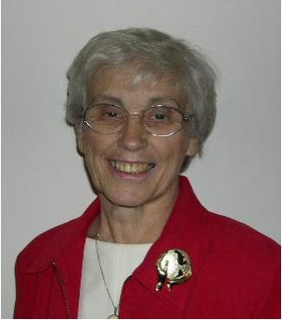
Nazarene
Missions
International

Gerry Perry, District Missions President

May: Missionary Health Care Month (Medical Plan)
May is Missionary Health Care Month (Formerly Medical Plan).
North American health insurance companies will not insure people living overseas. Therefore, the world Mission Department provides medical, dental, and vision coverage to contracted missionaries and their dependents. This coverage includes doctors, hospitals, prescription medicine, and optical, dental, and auditory expenses. Life insurance and long-term disability policies are also included.

NMI through Missionary Health Care (formerly Medical Plan) helps provide for missionaries’ medical needs. The more we give the more this allows the World Mission Department to invest more resources in church planting and evangelism worldwide.

Ways to participate are through Memorial Roll, Distinguished Service Award, Gifts from the Heart, and/or Medical Health Care offerings.

District NMI Convention – May 24-25, 2006. Speaker will be Dr. Aguiar Valvassoura, Pastor of Campinas Church of the Nazarene, Brazil. Dr. Robert Collins, Retired Missionary to Brazil will translate.

President’s Reports have been sent. If you have not received your forms please call Ruth Anne Gardner, District NMI Secretary, at 781-598-3668 or email her at ruthieag70@msn.com. Please feel free to call her or Gerry Perry, President, (781-792-2824 or email: gerryperry@adelphia.net if you have any questions.

Several things you need to know to prepare for District NMI Convention …

1. Clothing, Crisis Care Kits and School Pal Packs will be collected at the District Convention. NOTE CHANGE: The cost for shipping is $12. per banana box. This covers both local shipping and the Kansas City shipping costs. The NMI Treasurer will send moneys to the appropriate parties. A check must accompany the delivery of boxes.

2. NMI Convention pre-registration is $8.00. $10.00 at the door. All delegates (including pastors, lay members of advisory board, presidents {year ending and newly elected}, and elected delegates) are to register. Every District Nazarene Pastor in attendance will be recognized and given a gift.

3. We need the help of all pastors and NMI presidents to participate in the Flag Processional on Wednesday night. Please contact Evelyn Thompson TODAY if you are willing to help. (Email: PEThompson815@wmconnect.com)

4. All Presidents and Pastors are invited to the President’s reception following the Wednesday evening service. All President’s and Pastors are free. Cost for other guests is $4.00 per person. We need a count so if you are bringing guests because they are traveling with you please contact Jenny Albertson at albertsons@cleanairforkidsus. Tickets will be available at the registration desk.

5. TESSers request that each church bring ONE new Bible to the convention to be taken to the Gulf Coast. Also, gift cards from Lowes, Home Depot, K-mart, Walgreens, nation-wide chain stores will help with building supplies and other household needs. Donations toward trip costs are also welcome. Money donations should be made out to “New England District NMI” and marked “Gulf Coast W/W trip.”

6. World Evangelism Fund (WEF) and District Missions Expense Allocation (DMEA) can be paid up to convention time. Mark it for the 2005-2006 church year.

7. The 90TH Anniversary Offering “Books for Pastors” is still on-going. We are approximately half way to our goal. An offering will be taken at the convention so we suggest you bring a check with you made out to the New England District NMI and mark it either “Books for Pastors Project” or “Children’s Ministries Books for Pastor’s Project.”

June: World Mission Broadcast Month
Why not apply for a personalized greeting from a world region to your church to make it more personal? Information is in the World Mission Broadcast packet.


Chaplaincy
Ministries

Sally Miller,
District Chaplaincy
Director

This is an exciting time to be in the service of our Lord Jesus as a Chaplain. New Ministry opportunities are opening to us. All New England District Chaplains and anyone interested in learning more about the ministry of Chaplaincy, are invited to gather together during District Assembly. I have arranged for us to use the Presidents Dinning Room at the back of the ENC cafeteria during breakfast on Saturday during Assembly, that's May 27th. Just go through the food line and purchase your breakfast and join us for a time of fellowship, sharing about the Chaplain's Retreat and updates on what’s new in Chaplaincy. See you at District Assembly!
Rev. Sally J. Miller
Chaplaincy Director

New England District Calendar

MAY
NWMS Emphasis: Medical Plan & Prayer

2 Mission Directors’ Meeting - AM - Nashua
2 WHC Board - PM - Nashua
6 NYI Convention
6 Children’s Bible Quizzing District Finals
8 District Assembly Planning Committee– Quincy
11 District Advisory Board – Quincy
13 ENC Commencement
24-25 NMI Convention - Quincy
25-27 District Assembly – Quincy
27 Assessment Weekend Testing - Quincy

Prayer Requests

Pray for all that will be happening during the Missionary Convention and District Assembly on May 24-27.
Pray for our cities and the rise in violence.
Pray for our young people’s protection from violence and the evil one.
Pray for the victims of the hurricanes.
Pray for the churches which were damaged.
Pray for our schools, our teachers, children, parents
Pray for our open churches.
Pray for the sick.
Pray for the lost.
Pray for the persecuted church.
Pray for revival in the district.
Pray for revival in every church.
Pray for our President and his family
Pray for all of our government officials.
Pray for the courts.
Pray for marriages.
Pray for the college.
Pray for our region and our generals.
Thank HIM for every opportunity to serve!

New England District Church of the Nazarene
PO Box 690513, Quincy, MA 02170-0513
Phone: 617-786-9496, Fax: 617-786-9574
E-mail: nedoffice@cs.com
Jossie Owens
District Superintendent
Vincent Crouse
Assistant District Superintendent

To view New England Ministers’ News online,
go to the New England District website:
www.nednaz.org.

One in Heart and Mind
Bible Reading for
May 2006

One in Heart and Mind
Bible Reading for
January 2006
The Bible Reading Schedule is from the “Year of the Bible” website. You may also read the daily reading on line at: http://yob.gospelcom.net/reading.php

1 1 Peter 3:13-4:11
2 1 Peter 4:12-5:14
3 2 Peter 1
4 2 Peter 2:1-19
5 2 Peter 2:20-3:18
6 James 1
7 James 2
8 James 3
9 James 4
10 James 5
11 Jude
12 Luke 1:1-25
13 Luke 1:26-56
14 Luke 1:57-80
15 Luke 2:1-21
16 Luke 2:22-38
17 Luke 2:39-3:9
18 Luke 3:10-38
19 Luke 4:1-21
20 Luke 4:22-44
21 Luke 5:1-16
22 Luke 5:17-39
23 Luke 6:1-19
24 Luke 6:20-42
25 Luke 6:43-7:17
26 Luke 7:18-43
27 Luke 7:44-8:18
28 Luke 8.19-39
29 Luke 8:40-9:9
30 Luke 9:10-27
31 Luke 9:28-48

The Bible Reading Schedule is from the “Year of the Bible” website. You may also read the daily reading on line at: http://yob.gospelcom.net/reading.php

