New England District Church of the Nazarene

New England Ministers’ News
Vol. 15, No. 3 March 2006

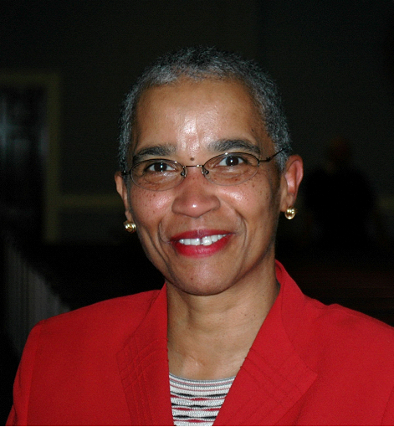
“We Must Live and Walk in Our Journey of Faith!”

Where did January go? Time moves so quickly! A number of saints around the district have been reading the scriptures in 90 days! This is day 39! It is truly a powerful, powerful experience! In Psalm 24:1 it says “The earth is the Lord’s and everything in it, the world, and all who live in it!” Our Father is in control of everything. We as a body of saints must live and walk by faith! It is becoming easier and easier to believe that all things are possible, if we just have the faith of a “mustard seed.” I read this story recently and I thought I would share it with you……. Look at it through eyes of faith, on the faith journey, and know that HE truly can do all things, “for nothing is impossible with God!

“I am reminded of the story of a pastor in Russia that pastored three churches 1000 miles apart, and he had no means of transportation except to walk. He would preach his first sermon at his home church, would leave that church, begin to walk to his destination, and would be transported there supernaturally. He would then preach his second sermon, would leave the second church, begin to walk to his next destination, and would be transported there supernaturally. He would preach his third sermon, would leave the third church, and begin his walk home and would be transported and arrive home -- all in a day's work.”

As I thought of this story, I heard the Lord say: I have called you, My people, to fulfill your destiny, and yet most of you do not know how you will get there. It seems absolutely impossible to your natural mind. But, I tell you, that nothing is impossible with Me. If you will only take the first step, I will transport you by My Spirit. Only believe, walk on in faith, and leave the rest to Me. You will be amazed at what I will do in your life, says the Lord.” In verse eight of Psalm 24, it says this:

⁸ Who is this King of glory? The LORD strong and mighty, the LORD mighty in battle.
⁹ Lift up your heads, O you gates; lift them up, you ancient doors, that the King of glory may come in.
¹⁰ Who is he, this King of glory? The LORD Almighty--he is the King of glory.

He is Lord of Lords and King of Kings and can do anything! We must walk by faith and believe in HIM!

Blessings,
Jossie

DISTRICT NEWS

Hispanic Conference
The Hispanic Conference will be held on Friday, March 17th at 7 p.m. and continue on Saturday the 18th from 9:30 a.m. - 3:00 p.m. at Worcester First. Please contact Rev. Juan Rivera for details. jegospel@adelphia.net

District Wide Choir for Gathering of the Saints
Please announce and encourage your people to join a mass choir at our Gathering of the Saints, March 4th at Wollaston. Music will be provided when we join together at 1:00 that day to rehearse for the opening praise anthem. It will be exciting as we combine our voices in one accord to sing "Great Is the Lord Almighty!" Contact Pastor Becky Turcott at 603-883-8345 if you have any questions.

District Installation Services Scheduled in March:
5 - Hingham, Pastor Jeremy Scott, 3:00 pm
12 - Duxbury, Pastor David Troxler, 3:00 pm
19 - Concord, Pastor John White, 10:45 am
19 - Mattapan, New Church Organization – New Alliance Church of Nazarene, Pastor Jean, 4:00 pm

~In Memory~~
We wish to mention the passing of Rev. Paul Foster Andrews (August 28, 1923 - January 26, 2006). He was a pastor on the New England District and is the father of Carol Newell, of North Street Community (Hingham) Church of the Nazarene.

March 4th, 2006
A Day of Prayer & Praise!

District Prayer Brunch
Lowell First Church
10:00 a.m. to 1:00 p.m.

then skate on down to the

Gathering of the Saints
Wollaston Church
2:30-5:30 p.m.



Sunday School
Ministries

Ron Keller, District Sunday School
Ministries Chairperson

Sunday School Ministries
2005-2009 Handbook
The brand new Sunday School Ministries Handbook has just been released. This book is filled with job descriptions, polity, and other articles to help our Sunday Schools become more efficient and effective. Every Pastor and Sunday School Superintendent should have a copy. You can order your copies by telephoning the Nazarene Publishing House at 1(800) 877-0700, at a cost of only $9.99.

Save For Boys and Girls Summer Camp
Now is the time for Sunday School leaders to encourage the children in our schools to begin to save for our excellent July 17 through July 22, Children’s Camp. Several of our churches budget “camp scholarship” money to help their children pay for camp tuition. The scholarships may be linked to Sunday School attendance, mission or ministry project involvement, behavior, bringing others to Sunday School, or on financial need.

Remember, everyone can save money by registering early for our Windsor Hills Camp. Payment of a $50.00 deposit by May 1, will save $30.00: By June 1, $20.00: By July three, $10.00. The full tuition of $265.00 will be charged for all who register on or after July 4.

All registration forms, mandatory health forms, adult and teen forms, and contact information are available at the camp web site www.whcamp.org Last summer, all but one space at camp was filled. This summer a few more spaces have been created: But they will fill up fast. Each church has an investment in our camp.—Be sure your children are not left out. Wait not, want not.

Teen Counselors In Training
Do you have some spiritually minded teens in your Sunday School who you would like to see gain experience and skills in working with children and in teamwork with other committed teens? The New England District’s popular Counselors in Training (CIT) Program is looking for several teens who want to minister and impact the lives of children at the July 17 to 22, Children’s Camp.

The CIT forms are available at www.whcamp.org An application and processing fee of $25.00 is required when the completed forms are submitted. All other expenses will be paid by Sunday School Ministries. The application fee will be refunded if a teen is not selected to be a CIT. Please inform your teen group’s leaders of this opportunity for your teens to minister and to learn.

Spiritually sensitive adult counselors and staff are also needed. Your questions about the CIT Program, Adult staff, or Children’s Camp information should be addressed to Rick Smith, Director at (802) 723-4824.

Vacation Bible School
By now plans for you Summer Vacation Bible School should be well underway. If not, there is still time to obtain information and materials to help you create a school that will impact the children and workers of your church. The brand new “The First Action Heroes” and the popular “J-Force, the Ultimate Truth” bargain priced leader’s kits are available at www.nph.org Almost every VBS results in new Sunday School and church members. Try it. You will like it.

Do You Have Sunday School Related Questions?
The following knowledgeable and friendly people always eager to try to answer your questions about Sunday School and small groups. Phone: Adult and Men’s Ministry Director George Hemway (603) 787-2586; Women’s Ministry Director Darlene Lamos (802) 635-2970; Prime Time Ministries Directors Dick and Louise Clifford (508) 295-2580; Sunday School Ministries Chairman Ron Keller (968) 777-3080.

Sunday School Reports
Thank you to Dan Beckwith who has faithfully served as our Sunday School Ministries Board Statistician for the past several years. His term of service expires on March 31, and we want to make his final report his best report—a 100% report. Please telephone or e-mail your Zone Chairman or Dan with your March Sunday School and Worship averages and your responsibility list/enrollment list totals on Sunday March 26. His phone number is (603) 362-5064. His e-mail address and your chairman’s addresses are in the NED Journal.



Nazarene
Youth
International
Jeff Lane, District
NYI President

NED NYI is looking to maintain an accurate list of persons involved in your local NYI ministry. We are asking that each church send an update of the best person to contact at your local church for NYI ministry. (This can be a youth worker, youth pastor, etc.) Please reply to me with local church name, their name, mailing address, phone number and email. We also want to announce two events that are coming up in the next few months.
On April 22, there will be a Spring Training for Youth Workers from 9-4 at Lowell Church of the Nazarene. The cost will be only 10 dollars per person, including lunch and training. We hope to have all of the persons who work with your local NYI here to receive training from Jon Middendorf, a nationally/denominationally recognized youth ministry guru.
On May 6, we will be having our annual NED NYI Convention in Nashua NH from 9-4. This event is for everyone involved in the local NYI, pastors, youth workers and students. The cost will be only 5 dollars, including lunch, training, etc. If you have any questions about these or others events with NED NYI please contact myself (Jeff Lane, 978-453-1063) or visit our website at www.nednaz.org/youth.html.

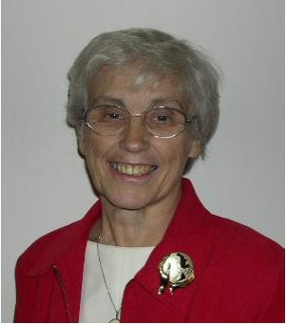
Nazarene
Missions
International

Gerry Perry, District Missions President

Nazarene World Week of Prayer
The Nazarene World Week of Prayer (February 26-March 4) culminates with the 14^{th+} District Prayer Brunch at the Lowell Church of the Nazarene on Saturday, March 4, at 10:00 a.m. with Phil & Martha Patalano, Angola. Cost: $7.50 per person, lunch included. There is nothing more important than for God’s people to come together for PRAYER. Please check for specific prayer requests for world regions on line at www.nazarenemissions.org beginning on Sunday, February 26. Share the requests with your congregations. Put them in your bulletins. Your prayers are needed more than ever.

Easter
In Experiencing the Cross Henry Blackaby writes “Christ’s death was God’s decisive deed in your life, conquering sin once and for all. The cross beckons you every day, with power to transform every detail of your existence as we begin to see Calvary from God’s perspective.” It is that transformation that we want to share with the world. Giving to the World Evangelism Fund (WEF) will take the message of the Cross to 150 nations. I am praying for you and your congregations as you participate in the Easter Offering For World Evangelism. Robert Prescott describes the WEF and Special Offerings for missions as the “cake” and “icing.” Our Church needs the “cake” of WEF in order to receive and manage the “icing” of mission specials.

April Emphasis Is Global Awareness
Are you making sure your church is aware of the great things God is doing through World Missions? World Mission DVD, Reading Books, Global Glimpses and Missionary Messenger help to keep you informed. Share these with your congregation.

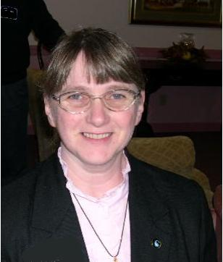
Chaplaincy
Ministries

Sally Miller,
District Chaplaincy
Director

Chaplaincy Ministries
The New England District Chaplains are looking forward to getting together before the Gathering of the Saints on March 4th. If you would like to join us to hear what exciting things God is doing in our ministry areas you are welcome. We will be meeting at the Wollaston Church at 1:00 p.m. Our plan is to share and network. May God continue to bless the work of the Chaplains who are serving beyond the walls of our churches.

In His Service…Rev. Sally Miller,
Chaplaincy Director

England District Calendar

MARCH
NMI Emphasis: Easter Offering, World Mission Magazine & Prayer

3 Ministerial Credentials and Studies - Quincy
4 Nazarene World Week of Prayer concludes
District NMI Prayer Luncheon – Lowell, 10:00 a.m.
4 Gathering of the Saints - Quincy, 2:30-5:30
4 World Day of Prayer
7-8 Clergy Retreat
14 Mission Directors’ Meeting - AM – Nashua
14 WHC Board - PM - Nashua
District Advisory Board - Quincy
16-18 ANSR 2006 Conference Technology and the Church
17-18 Hispanic Conference - Worcester (Fri. 7 p.m., Sat. 9:30-3:00)
16-19 NYI Festival of Life – ENC
25 District NMI Council – Lowell
District Assembly Planning - Quincy

Prayer Requests

Pray for our cities and the rise in violence.
Pray for our young people’s protection from violence and the evil one.
Pray for the victims of the hurricanes.
Pray for the churches which were damaged.
Pray for our schools, our teachers, children, parents
Pray for our open churches.
Pray for the sick.
Pray for the lost.
Pray for the persecuted church.
Pray for revival in the district.
Pray for revival in every church.
Pray for our President and his family
Pray for all of our government officials.
Pray for the appointment of the Chief Justice.
Pray for the courts.
Pray for marriages.
Pray for the college.
Pray for our region and our generals.
Thank HIM for every opportunity to serve!

New England District Church of the Nazarene
PO Box 690513, Quincy, MA 02170-0513
Phone: 617-786-9496, Fax: 617-786-9574
E-mail: nedoffice@cs.com
Jossie Owens
District Superintendent
Vincent Crouse
Assistant District Superintendent

To view New England Ministers’ News online,
go to the New England District website:
www.nednaz.org.

One in Heart and Mind
Bible Reading for
March 2006

One in Heart and Mind
Bible Reading for
January 2006
The Bible Reading Schedule is from the “Year of the Bible” website. You may also read the daily reading on line at: http://yob.gospelcom.net/reading.php

1 Acts 11.1-30
2 Acts 12.1-25
3 Acts 13:1-22
4 Acts 13.23-43
5 Acts 13:44-14:7
6 Acts 14:8-15:2
7 Acts 15:3-21
8 Acts 15:22-16:5
9 Acts 16:6-24
10 Acts 16:25-17:9
11 Acts 17:10-34
12 Acts 18:1-23
13 Acts 18:23-19:20
14 Acts 19:21-41
15 Acts 20:1-16
16 Acts 20:17-38
17 Acts 21:1-21
18 Acts 21:22-40
19 Acts 22:1-23
20 Acts 22:24-23:11
21 Acts 23:12-35
22 Acts 24:1-23
23 Acts 24:24-25:12
24 Acts 25.13-27
25 Acts 26:1-23
26 Acts 26:24-27:12
27 Acts 27:13-38
28 Acts 27:39-28:10
29 Acts 28:11-31
30 Mark 1:1-20
31 Mark 1:21-45

The Bible Reading Schedule is from the “Year of the Bible” website. You may also read the daily reading on line at: http://yob.gospelcom.net/reading.php

