New England District Church of the Nazarene

New England Ministers’ News
Vol. 15, No. 2 February 2006

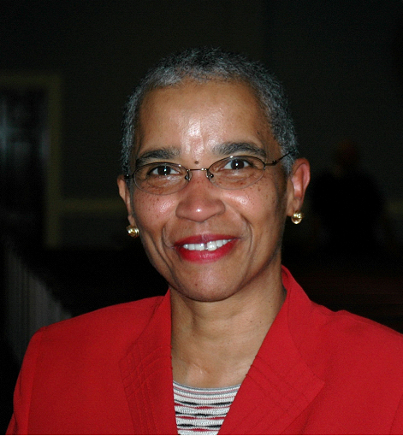
“New Beginnings And New Challenges”

Deuteronomy 1:6-8

Greetings Sisters and Brothers! Happy New Year! I love the sound of those words! Happy New Year! The Lord has allowed each of us to cross over into another year! I do not take it lightly, as it is indeed a true gift from our Heavenly Father. New beginnings and New challenges for each New day in 2006! I am humbled by the number of individuals who are reading along with me the Bible in 90 days. Furthermore, I am also humbled by how many folks who are reading the scriptures in one year! To God be the glory. I have always tried to stay consistently in the Word, but I have never taken up the challenge, to read the Word totally in 90 days. It is indeed a new beginning for me with so many new insights and connections. Have you found it to be a new venture with wonderful new insights? Throughout the scriptures God is telling us “not to be afraid and to totally believe in HIM!” In Deuteronomy 1:6-7, God is telling the Israelites that “they have stayed long enough at this mountain and that they must break camp, crossover, and advance into the hill country!

As we cross over into a New Year, I am reminded by the Holy Spirit, that as saints in the Body of Believers, we may have stayed too long in some places. It is time to move on and advance the Kingdom of God.

We may have stayed long enough in our valleys!
We may have stayed long enough in our areas of pain!
We may have stayed long enough in our seas of doubt and
discouragement!
We may have stayed long enough in yesterday’s mistakes!
We may have stayed long enough in our dreams deferred!

It is time to “break camp” and move on looking through new eyes at new opportunities for ministry. It is time my sisters and brothers to advance into the new challenges that HE sets before each and every one of us in this new year of 2006! It is time to “break camp” and go and tell others about the saving grace of Jesus Christ! In verse 8, it says, “See, I have given you this land! Can’t you see it also? God has given us this land to have Passion + Action + Courage + Excitement about telling the world about HIM! I look forward to hearing from you about your reading of scripture and conquering the land for Jesus Christ! Happy New Year! To God be the Glory! Have a truly great year in the Lord!

Blessings,
Jossie

Please note the following change of date:

The Gathering of the Saints

March 4, 2006

Wollaston Church of the Nazarene

2:30 – 5:30 p.m.



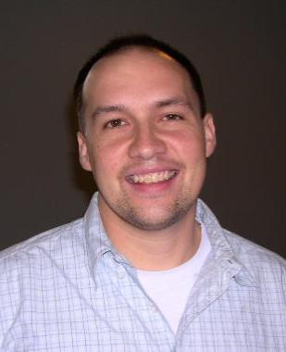

Nazarene
Youth
International

Jeff Lane, District
NYI President

Festival of Life is Coming Soon!!
This yearly gathering of students from all over the Eastern seaboard is a celebration of God's work in the lives of students from Maine to Virginia through local NYI ministries. During this four day event held on the campus of Eastern Nazarene College students will have opportunity to take part in discipleship training, athletic competitions, engaging praise and worship services, as well as other creative outlets. For more information you can see our webpage. The dates are as follows:
February 11 District Festival of Life at Lowell Church of the Nazarene
March 16-18 Regional Festival of Life at Eastern Nazarene College



NYC 2007
It's time to register your teens for NYC 2007! The financing for NYC 2007 will be a little different than in years past and will include two parts:

1.The registration/conference fee ($450) is paid directly to Kansas City and can be paid on-line.

2. The district fee ($800) pays for food, lodging and travel and is sent to New England District NYI.

The payment schedule is as follows:

Dates Due Amount Payable to
Upon Registration $100 waterfirewind.com
May 15, 2006 $100 waterfirewind.com
July 15, 2006 $100 waterfirewind.com
Sept. 15, 2006 $150 waterfirewind.com
Nov. 15, 2006 $200 NED NYI
Jan. 15, 2007 $200 NED NYI
March 15, 2007 $200 NED NYI
May 15, 2007 $250 NED NYI

Payments can always be made in advance. No payment under $100 will be accepted by www.waterfirewind.com and no advanced payments under $50 will be accepted by NED NYI.

The website for NYC 2007 provides information about the event and how to get sponsors, advertising, and registration details, etc. can be found at: www.waterfirewind.com

For more information, please contact our district NYC coordinator, Jim Abrams at: 401-431-0371 or rumfordrev@hotmail.com.

For more information on NYI events, see our website: www.nednaz.com and click on "Youth."

Upcoming Youth Events
February 4: Quiz Meet, Nashua Community Chapel
February 10-11: District Festival of Life, Lowell Church of the Nazarene
February 17-19: Senior High Retreat 2006
April 22: Youth Workers Spring Training at Lowell First Church, April 22, 9 a.m. to 4 p.m.



Sunday School
Ministries

Ron Keller, District Sunday School
Ministries Chairperson

Boy’s And Girl’s Summer Camp
Children’s Camp at our Windsor Hills Camp, begins Monday morning July 17, and runs through Saturday morning July 22. Registration forms, health forms, adult staff forms, teen counselors in training applications and other camp information are posted on the camp web site at www.whcamp.org Because of the success of last year’s boy’s and girl’s camp a few more beds or spaces will be made available. But space will fill up quickly. Early registration is advised.

Prices for most everything have gone up, but the cost for this summer’s camp will remain the same as last summer. For those who submit applications and a $50.00 deposit by May 1, 2006, the cost will be only $235.00: By June 1, the cost will be $245.00: By July 3, $255.00: And after July 10 the cost will be $265.00. Some partial scholarships may be available. Contact Ron Keller for scholarship information at (978) 777-2060.

New Hampshire state law requires counselors and staff to undergo a criminal records background check and physical examination. If you would like to invest a week of your life to help a child enjoy a lifetime relationship with Jesus, please, as soon as possible, contact Rick Smith, our children’s camp director, at (802) 723-4824.

Vacation Bible School Supplies
Our Nazarene Publishing House has just released their new “First Action Heroes” Vacation Bible School materials. A sample kit (with a money-back guarantee) is available for only $64.99 from www.nph.com. Type “VBS” into the search box. NPH continues to market the popular “J-Force, the Ultimate Truth” VBS materials. That kit is available for only $59.95.

Yes, VBS is always work.—Work for the Kingdom of God.—Work for the sake of the children.—Work that will be rewarded in eternity. Pray, pick a director, pick a date, pick out your colorful and cool Nazarene materials, publicize early and often, do your best, and leave the rest up to God.

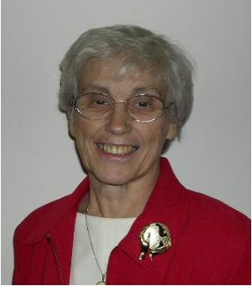

Nazarene
Missions
International

Gerry Perry, District Missions President

Alabaster Offering
It is ALABASTER OFFERING time again. We have opportunity twice a year to give our coins or dollars to literally build the Kingdom. Thank you to those of you who have given in September to purchase land and construct places for people to worship, heal, learn, and grow spiritually. We encourage every church to participate this February in this valuable ministry. No amount is too small. 100% of the offerings go to construction. 20% is used for multi-cultural ministry in the US and Canada and 80% goes to other lands. Several churches on our district have benefited from Alabaster - Brockton Haitian, Pawtucket Embaixadores, Dorchester Amis de la Sagesse and Quincy Chinese to name a few. When we give we help our neighbors as well as many others around the world.

Nazarene World Week Of Prayer
The Nazarene World Week of Prayer is scheduled for February 26-March 4. Each day we will pray for a different World Region starting with Africa on Sunday. Prayer requests will be available on line at www.nazarenemissions.org. We suggest you copy them and make them available to your congregation. The week will close on Saturday, March 4, 10:00 a.m., with the annual District Prayer Brunch at Lowell Church of the Nazarene. Phil & Martha Patalano from Luanda, Angola, will be the speakers. Special music will be by Lynn Shaw and the Wareham Worship Team and the Fitchburg-Leominster Hispanic Church. Cost is $7.50 per person. This is a valuable prayer time for our district to pray together for Nazarene world and home salvation needs and concerns.

March Emphasis: Easter Offering For World Evangelism Fund
Presently, according to the KC report on 12-21-2005, the churches on the New England District have paid 53.75% towards the WEF. Even though Easter is in April this year we still need your participation to meet our obligation of 100% payment. When sending in funds make sure you mark them for the 2005-2006 church year. Pray, plan and prepare early to make the Easter offering a special time of giving to Jesus, Our Savior.

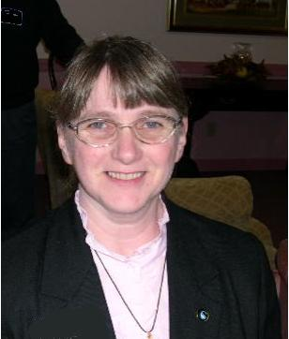

Chaplaincy
Ministries

Sally Miller,
District Chaplaincy
Director

New England District Chaplains
I am pleased to report New England District Chaplains are organizing. For years many who served as Chaplains did so alone. Many of those serving through the years have been doing so part time. Because no one knew where these ministries were taking place the one giving ministry had no support. But now things are finely changing. Even the part time Chaplain, both clergy and lay, can be certified or endorsed by the church. With this endorsement comes a system of support. Education in the form of Workshops, assess to the Chaplains prayer line for prayer support, retreat opportunities, and more. I have been in touch with 35 people who are interested in Chaplaincy, are part time or full time Chaplains in the last few weeks.
Chaplaincy is one of the growing edges of the Church of the Nazarene. I praise God for the support of the General and Regional Church in developing this ministry.
All of you who are registered Chaplains, please remember to get your applications for retreat in before Feb 15.
May God continue to bless you.
Chaplain Sally Miller,

District Director

Reynolds Institute Spring Classes
Two courses are being offered this spring:

Developing a Missional Church - Intensive Format at Windsor Hills
Instructor: Paul Willette
Mar. 31-Apr. 1; Apr. 28-29; May 19-20

Introduction to Christian Ministry
Tuesdays at Lowell First
Instructor - Ken Stanford
Mar. 28-Apr. 18 and May 9 and 16

England District Calendar

FEBRUARY
NMI Emphasis: Alabaster & Prayer

2-4 Vision New England’s Congress 2006 – Boston
10-11 NYI District Festival of Life, Lowell
17-19 Senior High Retreat
25 District Finance Committee - Quincy
26 Nazarene World Week of Prayer begins

Prayer Requests

Pray for our cities and the rise in violence.
Pray for our young people’s protection from violence and the evil one.
Pray for the victims of the hurricanes.
Pray for the churches which were damaged.
Pray for our schools, our teachers, children, parents
Pray for our open churches.
Pray for the sick.
Pray for the lost.
Pray for the persecuted church.
Pray for revival in the district.
Pray for revival in every church.
Pray for our President and his family
Pray for all of our government officials.
Pray for the appointment of the Chief Justice.
Pray for the courts.
Pray for marriages.
Pray for the college.
Pray for our region and our generals.
Thank HIM for every opportunity to serve!

New England District Church of the Nazarene
PO Box 690513, Quincy, MA 02170-0513
Phone: 617-786-9496, Fax: 617-786-9574
E-mail: nedoffice@cs.com
Jossie Owens
District Superintendent
Vincent Crouse
Assistant District Superintendent

To view New England Ministers’ News online,
go to the New England District website:
www.nednaz.org.

One in Heart and Mind
Bible Reading for
February 2006

One in Heart and Mind
Bible Reading for
January 2006
The Bible Reading Schedule is from the “Year of the Bible” website. You may also read the daily reading on line at: http://yob.gospelcom.net/reading.php

1 Matthew 22.23-22.46
2 Matthew 23.1-26
3 Matthew 23.27-24.14
4 Matthew 24.15-51
5 Matthew 25.1-30
6 Matthew 25.31-26.13
7 Matthew 26.14-35
8 Matthew 26.36-56
9 Matthew 26.57-75
10 Matthew 27.1-26
11 Matthew 27.27-56
12 Matthew 27.57-28.20
13 Acts 1.1-26
14 Acts 2.1-21
15 Acts 2.22-47
16 Acts 3.1-26
17 Acts 4.1-22
18 Acts 4.23-5.11
19 Acts 5.12-40
20 Acts 5.41-6.15
21 Acts 7.1-22
22 Acts 7.23-47
23 Acts 7.48-8.13
24 Acts 8.14-40
25 Acts 9.1-25
26 Acts 9.26-43
27 Acts 10.1-23
28 Acts 10.24-48

The Bible Reading Schedule is from the “Year of the Bible” website. You may also read the daily reading on line at: http://yob.gospelcom.net/reading.php

