New England District Church of the Nazarene

New England Ministers’ News
Vol. 15, No. 1 January 2006

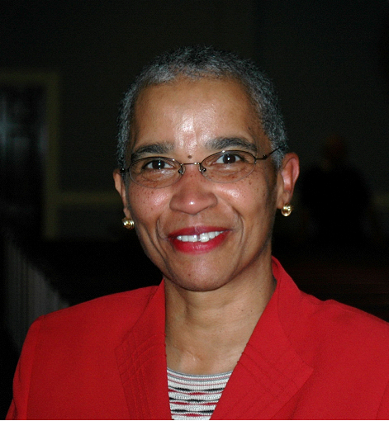
He Will Keep HIS Promise

Greetings Saints:

Where has the time gone? As I look back, time seems to move increasingly faster? Do you feel the same way? I want to wish each and every one of you a wonderful Advent Season! The coming of the King! May you and your families experience the hope, peace, joy, and love of our Lord and Savior. As I drive around the district and listen to talk radio, I am still amazed by the marketplace discussion, regarding what should this season be called? What should be the name of the trees be? Should the trees be called Christmas trees or holiday trees? Some folks are just so fearful of the name of Jesus Christ! Who ever would have thought that we would have to be politically correct on what to call a tree? This discussion caused me to reflect on the words in II Peter chapter three, regarding how people in the last days will forget the promise of His return and say “Where is the promise of His coming?”

My brothers and sisters, we who are believers must not forget “this one thing, With the Lord a day is like a thousand years, and a thousand years are like a day. The Lord is not slow in keeping His promise, as some understand slowness. He is patient with you, not wanting anyone to perish, but everyone to come to repentance.” What are we to do until He returns as He has promised? We are to “live holy and godly lives as we look forward to the day of God and speeds its coming” (II Peter 3:8-12). Have a wonderful, wonderful Christmas season and a truly happy New Year as we wait with patient endurance for the Promise of His Coming!

Blessings,

Jossie

Passion Action Courage Excitement!
Please note the following change of date:

The Gathering of the Saints

March 4, 2006

Wollaston Church of the Nazarene

2:30 – 5:30 p.m.





Nazarene
Youth
International

Jeff Lane, District
NYI President

Youth Workers Spring Training will be held at Lowell First Church of the Nazarene on April 22 from 9 a.m. to 4 p.m. This is a gathering for a one-day training event with Jon Middendorf, a youth working guru from Oklahoma, and several other youth workers from the New England area. This event will provide a time of training and discussion about contemporary issues in youth ministry. These events are geared to not only inform, but also transform your local leaders towards more effective ministry through your local NYI. For more information about this training event or other information regarding starting or strengthening your local student ministry check out our webpage at http://www.nednaz.com/youth.html.

Upcoming Events
January 6-7: Quiz Meet, Loudon, NH
January 20-22: Junior High Retreat, Snowbound 2006
January 28: NYI Council Meeting, 10 a.m. -1 p.m., Lowell First Church
February 4: Quiz Meet, Nashua Community Chapel
February 10-11: District Festival of Life, Lowell Church of the Nazarene
February 17-19: Senior High Retreat 2006



Sunday School
Ministries

Ron Keller, District Sunday School
Ministries Chairperson

Teacher Training
The days of giving a new Sunday School teacher a handful of Sunday School materials and setting them free in a classroom should be ancient history. Teachers need to be trained. They need job descriptions. They need a variety of materials with which to work. Teachers need to learn to pray for and with their students. They need training to become soul winners and encouragers.

Christian Lay Training courses are available for Sunday School teachers to get basic teacher’s training and to get continuing teacher education. Visit the CLT website at
http://www.nazarene.org/ssm/clt/index.html and discover a plethora of courses for teachers and small group leaders. Not only can they use traditional book methods, but training is also available on-line. There are no excuses for untrained teachers.

Summer Children’s Camp
Children’s Camp at our Windsor Hills Camp, will run from Monday morning July17 through Saturday morning July 22. Please mark your new calendars and publicize the camp.
Rick Smith, Camp Director, is planning the best camp yet. Information is available at www.whcamp.org.

Counselors and staff will be needed. All must have a criminal background check and a physical examination. Please pray about investing a week of your life to help a child enjoy a lifetime of relationships with Jesus. To enlist or for questions phone Rick at (802) 723-4824.

Nazarene Sunday School Supplies
The majority of materials in our Sunday Schools should be Bible based, holiness curriculum. Our Nazarene Publishing House publishes excellent children, teen and adult Bible-based, holiness Sunday School materials. There is a wonderful variety from which to choose. Be sure you have enough. Check out what is available at www.nph.com.

Children’s Bible Quizzing
Bible Quiz Director Patsy Malas is doing a wonderful job leading the children of our district in quizzing. Kids who learn the Word receive a foundation that will never be destroyed. Telephone Patsy at (617) 770-1946 with your questions or for quiz meet dates.

First District Men’s Retreat
Our first all District Men’s Retreat is scheduled for September 15-17, 2006. Our District Adult Director, George Hemway is laying the plans for a super weekend at our Windsor Hills Conference Center. More information will follow. Mark your calendars.

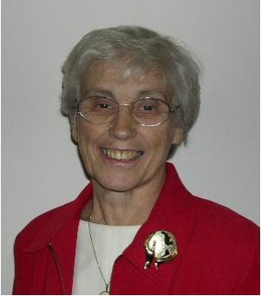

Nazarene
Missions
International

Gerry Perry, District Missions President

January Emphasis
The January Emphasis is NAZARENES IN VOLUNTEER MINISTRIES – now known as MISSION CORPS.

This summer there are several opportunities for volunteer service in the area of Work and Witness on our district. The teens and sponsors will be going to the Gulf Coast in July. Applications are due immediately. Contact Martha Wilson at pastormartha@verizon.net. A team will be going to Russia this summer. (Contact Bruce Monk, Nashua church, MJMonk@aol.com.) A team under the direction of Richard and Ruth Jarvis will be going to Bulgaria in July. Contact the Jarvises at Rrjarv@comcast.com for information. Work & Witness teams are also needed at Camp Windsor Hills. Any one of these is a great opportunity to experience missions first hand!

The District Missions Expense Allocation is due JANUARY 1
What does DMEA help to support? District Convention expenses, children and youth ministries such as Jamborees and camps, meals & travel for District Council meetings, District Journal, Audiovisuals, printing and postage, telephone, General Convention delegates, Regional Conferences etc. This spring DMEA will help to fund Leadership Workshops for the Connecticut/Western MA Mission Area in January and the Vermont/No. Vermont Mission Area in April, the Prayer Brunch at Lowell in March and the Convention in May.
Thank you so much for your financial support. We are here to serve you!

Dr. Daniel Ketchum, field coordinator for Asia Pacific region, has been elected Director of Nazarene Missions International.

Looking Ahead:
FEBRUARY IS ALABASTER OFFERING MONTH. Participation is the key. Alabaster helps the eight world regions, including Canada and USA, to purchase land and construct places for people to worship, heal, learn, and grow spiritually.

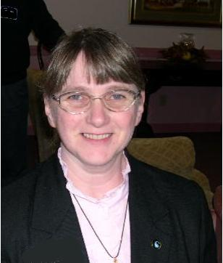

Chaplaincy
Ministries

Sally Miller,
District Chaplaincy
Director

Chaplain, you are not alone just because you work beyond the walls of the church. The General, Regional, and District church are here to support you with prayer, educational opportunities, networking opportunities and fellowship.

We have an exciting year ahead. Please put the following events on your calendar.

Chaplains Retreat
Plan on attending the Northeast Regional Nazarene Chaplains Retreat, April 21-23, With Dr. Lyle Pointer, Beaver Hollow Conference Center, Java Center, NY. Registration must be received by February 15, 2006. If you have not already received an application in the mail, please call or email me and I will get one to you. (508-540-6531) or ( sallydennis1@netzero.net)

Pastors if you have lay chaplains in your church or if you are a part time chaplain and would like to attend this retreat please contact me. This retreat is for chaplains that have been endorsed or certified by our denomination. I will be happy to send an application for endorsement or certification to anyone involved in chaplaincy ministry.

District Assembly
We will be meeting again for lunch. Please plan to attend.

District Equipping Day
Our workshop at the last district workshop day was so successful that we will be planning another great day for you to participate in.

Happy New Year, May God fill your year with blessing as you serve Him,
Rev. Sally Miller
District Chaplaincy Director

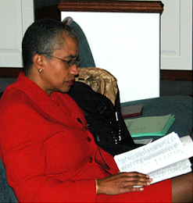

2006
Bible
Reading
Challenge

I believe one of the most important things that we do as pastors and as Christians is to read His Holy Word every single day! In order to sense, know, and experience the FIRE, we must be in our Word daily! I feel that it is part of my responsibility to challenge you and all of our people on the District to stay in the Word. We must keep our swords lifted high and with us at all times. I will always be challenging you and advising you to lead your people to have a daily disciplined devotional time. I’m hoping and praying that they are joining us in reading the Bible for five minutes every day using the One in Heart and Mind plan.

This year I’d like to offer you a new challenge as an alternative to the five minute plan. Enclosed is a new schedule for reading the Bible in 90 days. You might ask the question, “why read it in 90 days? The answer is that I have never done it before in that time period. I love a challenge! The Bible in 90 Days is only $14.99 at CBD (www.christianbook.com, stock #RY93351X). If you are not interested in taking the 90 day challenge, perhaps some of your people might be! Please share the above information with them. I have had a number of the laity ask to be a part of the challenge. (For more information, see www.biblein90days.com.)

Accepting this challenge will not make you grow spiritually. Being immersed in the Word daily and allowing the Holy Spirit to change you will!

If you are interested in reading along with me, please let me know by contacting me via phone or drjossie@comcast.net It would be a great deal of fun to share the experience with you! We will be starting the reading on January 1, 2006.

England District Calendar

JANUARY

NMI Emphasis: Volunteer Ministries & Prayer

1 District Mission Expense Allocation due
7 SSM Board -
12 District Advisory Board - Quincy
17 Mission Directors – AM – Nashua
17 WHC Board PM - Nashua
20-22 SNOWBOUND - Junior High Retreat
21 District Nominating Committee – Nashua
28 District SSM, NMI, NYI Team Planning
28 Children’s Quizzing – Winter Invitational

Prayer Requests

Pray for our cities and the rise in violence.
Pray for our young people’s protection from violence and the evil one.
Pray for the victims of the hurricanes.
Pray for the churches which were damaged.
Pray for our schools, our teachers, children, parents
Pray for our open churches.
Pray for the sick.
Pray for the lost.
Pray for the persecuted church.
Pray for revival in the district.
Pray for revival in every church.
Pray for our President and his family
Pray for all of our government officials.
Pray for the appointment of the Chief Justice.
Pray for the courts.
Pray for marriages.
Pray for the college.
Pray for our region and our generals.
Thank HIM for every opportunity to serve!

New England District Church of the Nazarene
PO Box 690513, Quincy, MA 02170-0513
Phone: 617-786-9496, Fax: 617-786-9574
E-mail: nedoffice@cs.com
Jossie Owens
District Superintendent
Gary W. Jones
Assistant District Superintendent

To view New England Ministers’ News online,
go to the New England District website:
www.nednaz.org.

One in Heart and Mind
Bible Reading for
January 2006

One in Heart and Mind
Bible Reading for
January 2006
The Bible Reading Schedule is from the “Year of the Bible” website. You may also read the daily reading on line at: http://yob.gospelcom.net/reading.php

1 Matthew 1
2 Matthew 2
3 Matthew 3.1-4.11
4 Matthew 4.12-5.12
5 Matthew 5.13-37
6 Matthew 5.38-6.15
7 Matthew 6.16-7.6
8 Matthew 7.7-8.4
9 Matthew 8.5-8.27
10 Matthew 8.28-9.13
11 Matthew 9.14-34
12 Matthew 9.35-10.23
13 Matthew 10.24-11.6
14 Matthew 11.7-30
15 Matthew 12.1-21
16 Matthew 12.22-42
17 Matthew 12.43-13.17
18 Matthew 13.18-43
19 Matthew 13.44-14.12
20 Matthew 14.13-36
21 Matthew 15.1-28
22 Matthew 15.29-16.12
23 Matthew 16.13-17.8
24 Matthew 17.9-18.7
25 Matthew 18.8-35
26 Matthew 19.1-22
27 Matthew 19.23-20.16
28 Matthew 20.17-34
29 Matthew 21.1-22
30 Matthew 21.23-46
31 Matthew 22.1-22

The Bible Reading Schedule is from the “Year of the Bible” website. You may also read the daily reading on line at: http://yob.gospelcom.net/reading.php

