New England District Church of the Nazarene
New England Ministers’ News

Vol. 13, No. 12 December 2005

Look at What God is Doing!

In the past few weeks, two of our district churches have received positive attention in their local newspapers. Some of the highlights are quoted below.

Operative word is ‘new’ at Church of the Nazarene
By Dan Champagne, Record-Journal

WALLINGFORD - The smell of new carpet still lingered in the Church of the Nazarene on Thursday. The smell of sawdust and wood flooring is due to follow.
Since being stalled as pastor on Jan. 16, the Rev. Herbert Bailey has brought with him ideas for several renovations that he said were long overdue.

“Changes needed to be made,” said Bailey, 41, the former associate pastor at the Manchester Church of the Nazarene. “I love the area and I think Wallingford is one of the nicest places in Connecticut. There is just so much possibility here.”
~
One of the first changes to the church, at 26 Parker Farms Road, was in the sanctuary. A new carpet was installed and the pews were taken out in favor of rows of padded blue chairs. The area can accommodate around 100 people; the church has about 40 members.
~
The lower level of the church is also getting a complete makeover.
~
Bailey also has a room reserved for a food pantry program he wants to open next year. He also hopes to hold outdoor concerts and services in the spring and summer.
~
“People probably have no idea what’s going on inside until they see something happen with the outside,” Bailey said. “Once they see the work we’ve done out there, I think they’ll come inside to check it out.”

Building God’s house
By Kyle Alspach, Sentinel & Enterprise


FITCHBURG - A sign outside Fitchburg Church of the Nazarene reads “Our Church Can Be Your Home.”
It’s an idea many people have taken to heart.
The church congregation has more than tripled in size - from 50 to 160 people - in the last five years.
I think people want to be involved in something that they see as alive, and going forward,” said Andy Belokur, pastor of the church. “They don’t want dead ritual.”
~
But a new sanctuary is on the way for the church, which is located at 800 South Street.
The 300-person building is nearly done and targeted for a Dec. 11 opening.
Belokur said the church’s modern worship style - with a full, live band and contemporary songs - is part of why people are flocking to the church.
But many of the people stay because they are finding answers to their spiritual questions, Belokur said.
“The truth from the Bible is relevant today,” he said. “It meets their needs.”

District News & Announcements
Dick Clifford is making himself available for Evangelistic Services on the District. As you know, he has served all of his pastoral ministry in New England. During that time he also held Revivals and Crusades in the eastern U.S., Guam, England, New Zealand, and the Philippines. He is ready to be used on a fee will offering basis in churches of any size. If he can be of service to your congregation, call: Home phone 508-295-2580; Cell 508-317-0400 or e-mail him at: randlclifford@msn.com.

Gary Jones has accepted a call to serve as pastor of the Manchester, Connecticut Church of the Nazarene.

The following churches are currently looking for pastors: Burlington, VT; Provident, RI First; Loudon, NH; Hingham, MA: Duxbury, MA; Preston, CT; No. Attleboro, MA; Quincy, MA Chinese. Pray that God will provide pastors and that these churches would be seeking God’s will.





Sunday School
Ministries

Ron Keller, District Sunday School
Ministries Chairperson

American Bible Society Offering
Since 1816 the American Bible Society has been distributing Bibles in the United States and around the world. They make low cost Scriptures, in several translations and languages, available for churches and individuals to purchase and to give away.

For several decades the Church of the Nazarene has received and ABS offering to help fund this worthy cause. December 11 is the date that has been scheduled for this year’s offering. Sunday School Ministries is responsible for receiving this year’s offering.

Encourage each Sunday School class to receive a special offering on December 11 or any December Sunday. The church treasurer should send a check for the offering to the General Treasurer, Church of the Nazarene. Multitudes of people do not have a Bible. Our generous offerings will help bring light and life to many.

Christmas Plans
Most of you already have your Christmas plans in motion. If not, may SSM suggest a few ideas that may help you grow your Sunday School and church. Encourage each class to have a Christmas party, social or event early in December. Before schedules become filled, get it on the calendar early. Involve class members, parents or sponsors to participate in parties for children and teens. People need fellowship and they need to be needed.

Plan for each class to share an evening of Christmas carols with church members who are unable to attend services, with neighborhood families, or nursing home residents. Choose a date and contact the Activities Director at the nursing home you will visit. Line up adults to drive. Have the children or teens make some cards or decorations to share with those who are visited. Recruit volunteers to prepare and serve refreshments after the caroling is completed. Enjoy the smiles of those who listen and those who sing.

How about having a different Sunday School class take responsibility for a song or brief program when the Advent Candle is lighted to begin each of the four Sundays of Advent? We need to find ways to get everyone involved in some form of ministry and praise to God.

End December with a challenge for people to resolve to give Sunday School a try, beginning with the first Sunday of January 2006. Challenge your teachers to be prepared with a well planned, relevant lesson.

Next Summer’s Children’s Camp
Give a child a gift that will be remembered forever. Give them the gift of a week at our
district Children’s Camp at our Windsor Hills Camp. July17-22, 2006 could be the week that will change their lives forever. Information is available at www.whcamp.org.

Order Nazarene Sunday School
Supplies
Holiness people need holiness Sunday School materials. Our Nazarene Publishing House puts out the world’s best children’s, teen’s and adult’s holiness Sunday School materials. There is a huge variety from which to choose. Be sure you have enough. Check out what is available at www.nph.com.

Remember, “Christian Lay Training” materials are available for you to use in training your teachers to be effective communicators of the gospel.

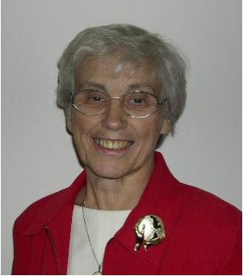

Nazarene
Missions
International

Gerry Perry, District Missions President

May the Christ of the cradle and
the cross fill you with his love,
peace and joy this season!

Let’s share His gifts this Christmas season through Nazarene Compassionate Ministries!

“No exercise is better for the human heart than reaching down and lifting another up.” (Author unknown)

“The King will reply, ‘I tell you the truth, whatever you did for one of the least of these brothers of mine, you did for me.’” (Matt. 25:40 NIV)

It seems that every day there is a new call for money but there have been so many disasters and the need is so great and the resources are so limited that we must continue to give.

As I am writing this news another disaster has hit our nation. A tornado touched down in Kentucky and Indiana killing several people and leaving many more homeless. All around the world there have been hurricanes, floods, mudslides, earthquakes and tornadoes. We are called to give to the least of these. As we focus on Compassionate Ministries this month we encourage you to copy the NCM Giving Calendar (See December Messenger) for your people and challenge them to give as the Lord directs.

A Christmas Gift for “Books for Pastors”: A wonderful way to have our gift keep on giving is to encourage our people to add “Books for Pastors” to their Christmas list. As a promotion, small gift boxes or decorated envelopes can be given out for each member of the congregation to return with $7 inside. “Books for Pastors” project is making Pastor’s libraries available, in their own language, to pastors in third world areas.

Child Sponsorship is another way to give a gift of love this Christmas.

Looking Ahead…
JANUARY 1 – District Missions Expense Allocation is due. Thank you for your support.



Nazarene
Youth
International
Jeff Lane, District
NYI President

NYC'07 is coming sooner than you think!
Nazarene Youth Conference 2007 ( www.waterfirewind.com) happens once every four years to rain God's grace into your life, to ignite the holy fire of God deep within your heart and breathe into your soul a movement of God that is life and world changing. NYC '07 is an experience you will never forget, a wondrous and embracing community of high school students.
Nazarene Youth Conference 2007 is a place of experience and community. The entire week reflects the life-transforming power of Jesus Christ. It is a dynamic, awe-inspiring, mind-blowing movement of God.
Above all else, NYC '07 is a place of experience - a place where students will meet the Living God through worship, the elements of creation, the gifts of others, and Jesus Christ in each person, as each of us investigate the truths of this Christian faith together.
For more information, contact Jim Abrams, NYC Coordinator at the youth page at www.nednaz.com. There you will all the info about NED NYI ministries.

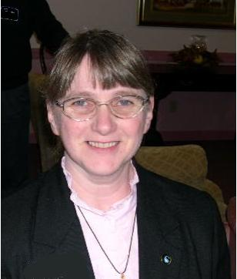

Chaplaincy
Ministries

Sally Miller,
District Chaplaincy
Director

What a great workshops we had at the District Equipping Day in November. We learned that there are now three categories of Chaplains.
1. The full-time chaplain
2. The part-time chaplain
3. The lay chaplain
The first and second would be people who are ordained. The lay chaplain is a lay person who does volunteer or paid chaplaincy ministry. This is the new category.
If you or anyone in your church is doing chaplaincy please let me know so that I can send an application for endorsement. Let's get prayer support and educational opportunities of our church working for every chaplain who is serving lay or ordained.
Email me at sallydennis1@netzero.net. May God bless you as you continue to minister beyond the doors of the church.
Rev. Sally Miller, District Chaplaincy Director

District Equipping Day - November 5th

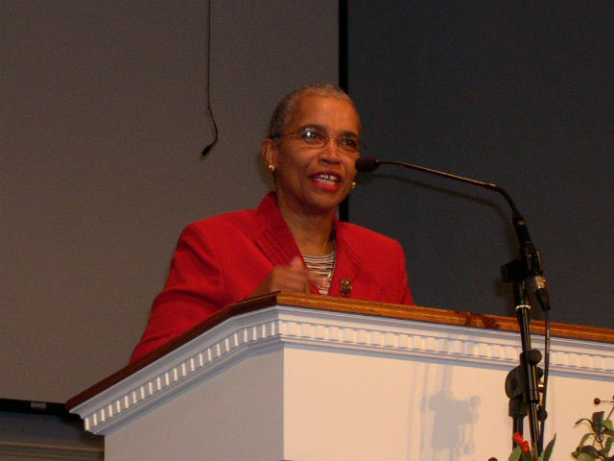

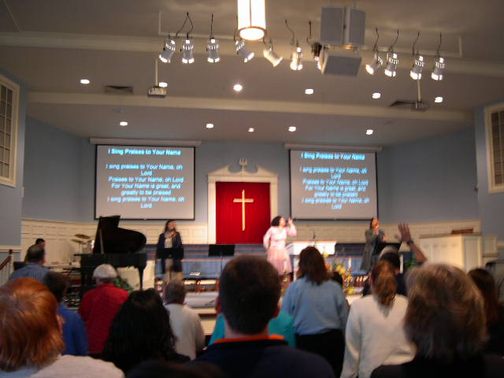

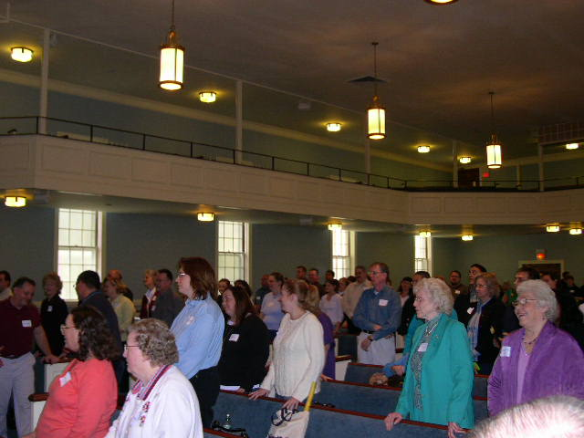

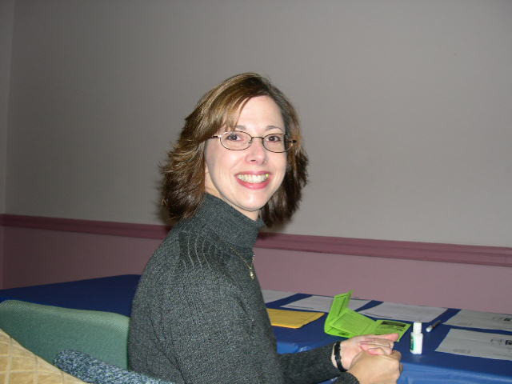

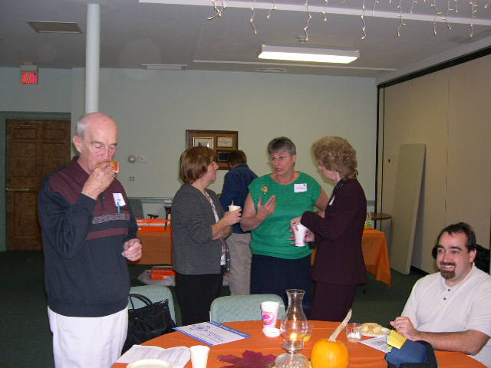

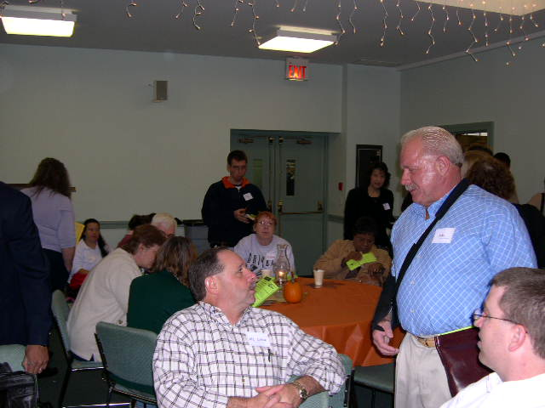

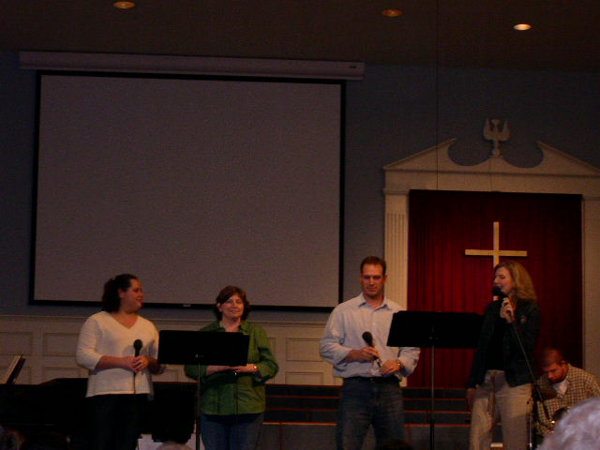

Don’t miss the 2nd Annual
All District
Gathering of the Saints
Wollaston Church
January 14, 2006
2:00 – 5:00 p.m.

New England District Calendar

DECEMBER

NMI Emphasis - Compassionate Ministries & Prayer

1 Crisis Care Kits due
2 District Ministerial Credentials Committee
25 MERRY CHRISTMAS!

Prayer Requests

Pray for the victims of the hurricane.
Pray for the churches which were damaged.
Pray for our schools, our teachers, children, parents
Pray for our open churches.
Pray for the sick.
Pray for the lost.
Pray for our president and his family
Pray for all of our government officials.
Pray for the appointment of the Chief Justice.
Pray for the courts.
Pray for marriages.
Pray for Sally Zink.
Pray for the college and our new president!
Pray for our region and our generals.
Thank HIM for every opportunity to serve!

One in Heart and Mind

Bible Reading for December 2005

1 | 1 John 1.1-2.11
2 | 1 John 2.12-29
3 | 1 John 3
4 | 1 John 4
5 | 1 John 5
6 | 2 John
7 | 3 John
8 | Revelation 1.1-18
9 | Revelation 1.19-2.17
10 | Revelation 2.18-3.6
11 | Revelation 3.7-22
12 | Revelation 4
13 | Revelation 5
14 | Revelation 6
15 | Revelation 7
16 | Revelation 8
17 | Revelation 9
18 | Revelation 10.1-11.7
19 | Revelation 11.8-12.6
20 | Revelation 12.7-18
21 | Revelation 13
22 | Revelation 14.1-13
23 | Revelation 14.14-15.8
24 | Revelation 16
25 | Revelation 17
26 | Revelation 18.1-18
27 | Revelation 18.19-19.10
28 | Revelation 19.11-20.10
29 | Revelation 20.11-21.8
30 | Revelation 21.9-22.5
31 | Revelation 22.6-21

The Bible Reading Schedule is from the “Year of the Bible” website.
You may also read the daily reading on line at: http://yob.gospelcom.net/reading.php

New England District Church of the Nazarene
162 Old Colony Avenue
PO Box 690513, Quincy, MA 02170-0513
Phone: 617-786-9496, Fax: 617-786-9574
E-mail: nedoffice@cs.com

Jossie Owens, District Superintendent
Gary W. Jones, Assistant District Superintendent

“Fan into flame the gift of God, which is in you.” 2 Timothy 1:6

