New England District Church of the Nazarene
New England Ministers’ News

Vol. 13, No. 7 July 2005

Praise The LORD- During Assembly Time!

Hebrews 10:25

In The Fruit of the Spirit Bible, it talks about the Church, and what it is all about for believers. I believe that we had true Church doing our recent District Assembly Time. The Lord answered prayer. I would like to share the ten reasons taken from the Fruit of the Spirit Bible why we come together as a Body of Believers. The church: It’s always there. There’s virtue in attending church, for here we meet with God and those who love Him. Why is this meeting time so special? You know why! Here are ten reasons for us to come together as the church and have a special time during Assembly time with the saints!

- There is one place that constantly reminds us that heaven exists—it’s the church. I believe we sensed a slice of heaven at various points during assembly time!
- God’s house is a constant reminder to the nation that the nation ought to be more like God’s house
- God’s house is a place of worship, and worship is the hassle-stopper. We experienced true worship during Assembly time at Wollaston Church.
- Those who constantly run without stopping for God eventually become all legs and no heart. May that never be so during Assembly time!
- Church is the place for teaching our children the life of faith. It is the place where they are ever in training to become tomorrow’s moral giants. It is my prayer that more of our youth begin to come during Assembly time and that they will want to come and be a part of something truly remarkable. We must invite them in to celebrate with us! To God be the glory! Great things He plans to do!
- There we live in a community of need—our brothers and sisters, like ourselves, have many needs during Assembly time. We can lift them up as they lift us.
- There is praise there, and praise keeps us from living in a world where despair is common. We celebrated during Assembly time some unique times in the Spirit!
- The Bible is read in church. Just to hear these living words of God during Assembly time gives us the power to triumph over our momentary problems.
- The gospel is preached there, and where the gospel is preached, people come to Christ. People came to Christ in a closer walk during Assembly time!
- Jesus is exalted there, and anywhere that Christ is exalted is a place where our own spirits soar, even during Assembly time!

Hebrews 10:25 is a call not just to worship, but to worship in a specific place, where altars are central, and where God is expected to show up, even during Assembly time!

Thank you so much for making District Assembly a wonderful time in the Lord! We had church! Can I ask a favor of the church? Over the next three months, could you pray and fast the noon day meal on July 15th, August 15th and September 15th with me? Great things will happen if we are a united team in both prayer and fasting. Please pray about this and perhaps email me and let me know if you are willing and able to commit.
Blessings,

Jossie

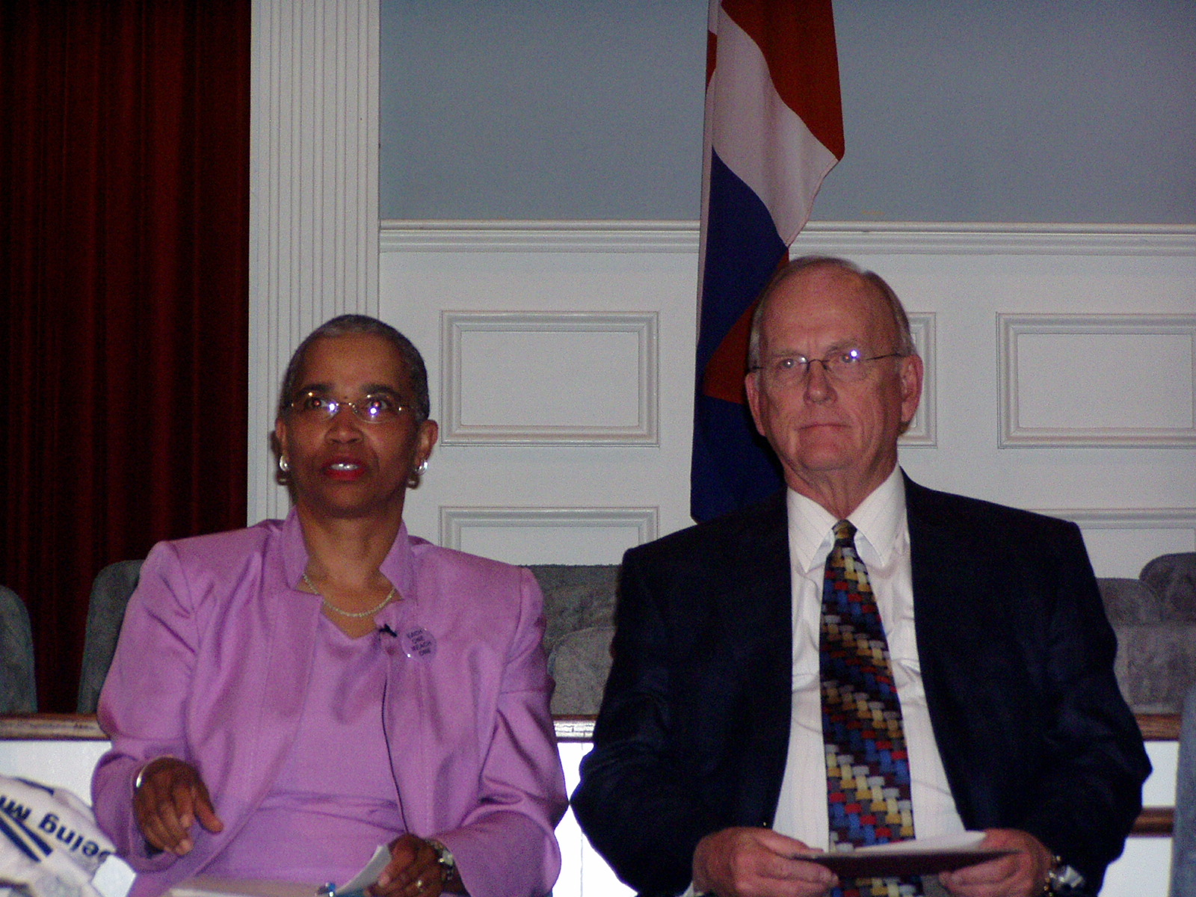

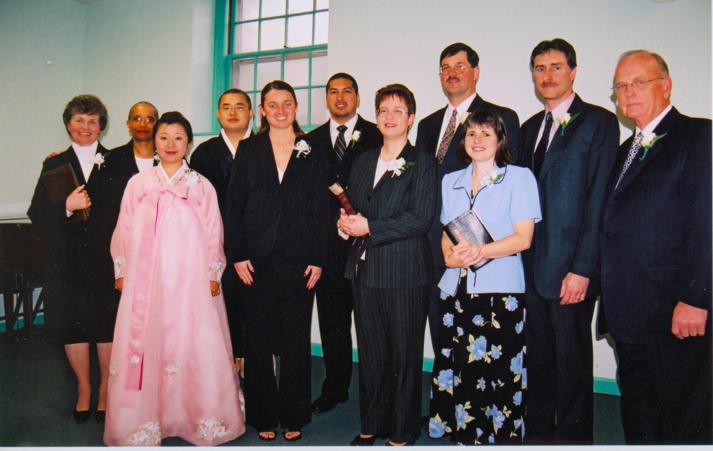

Special Memories of Assembly 2005 … General Superintendent Talmadge Johnson and District Superintendent Jossie Owens, our 2005 Ordination Class, and the All Saints picnic following assembly.

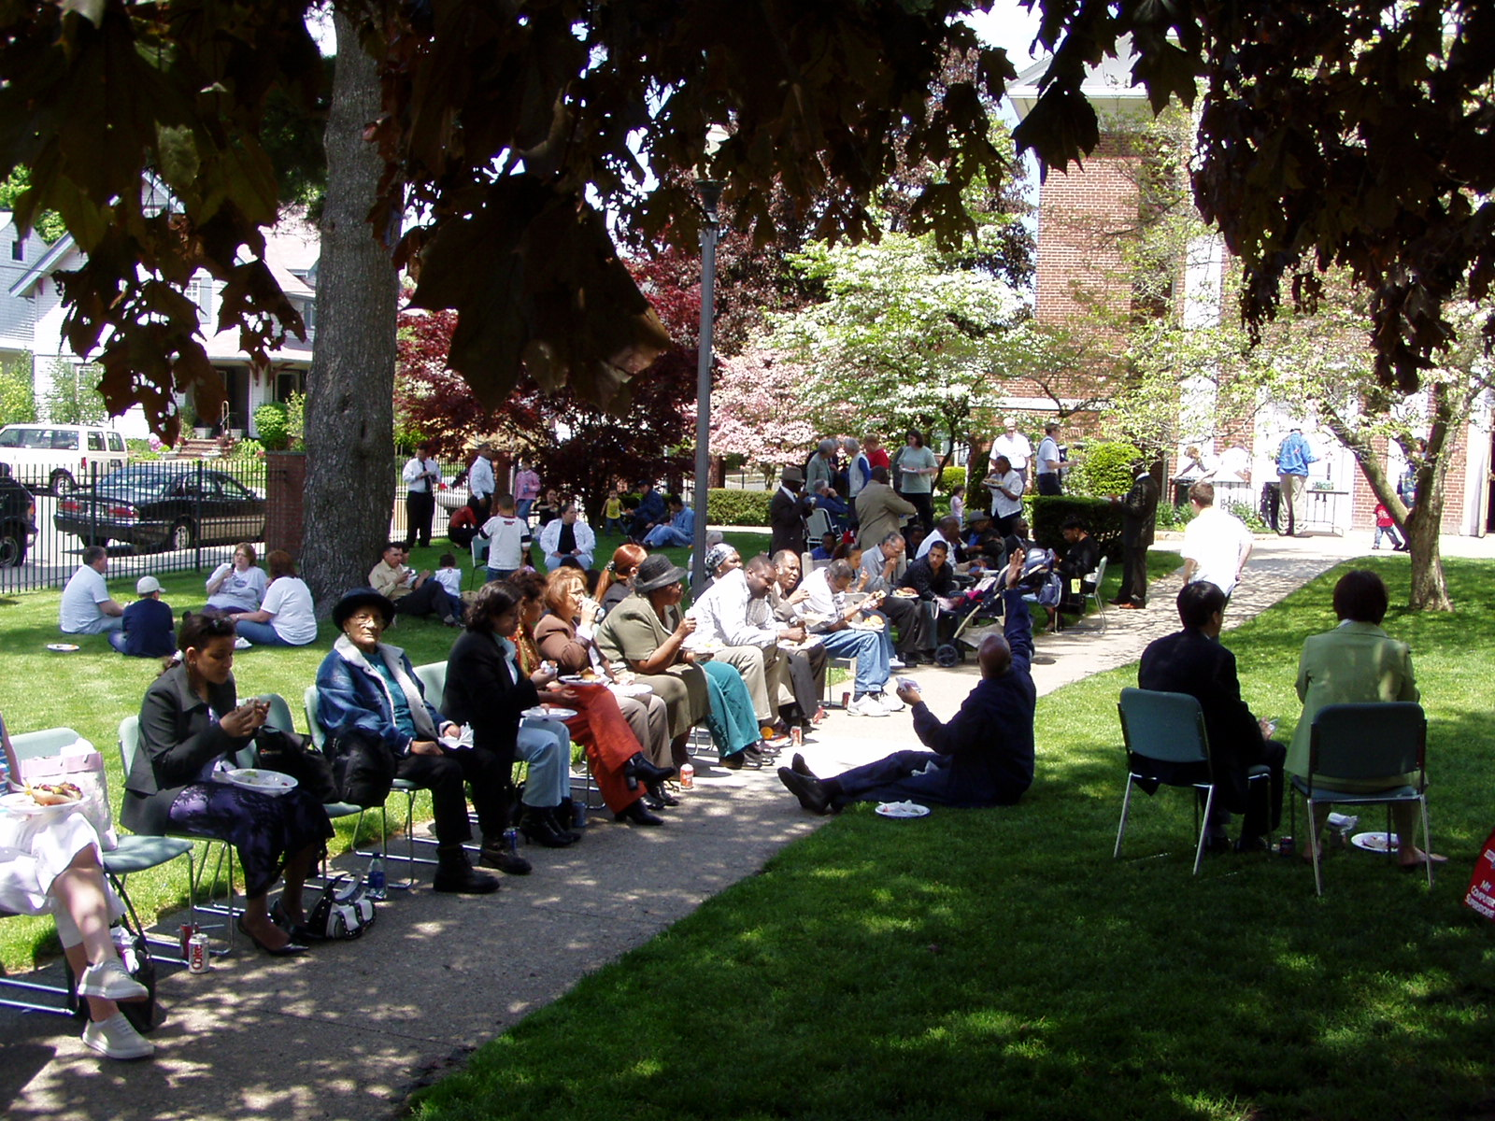

Church Changes
Ken Stanford has accepted a call to the South Weymouth church.
The following churches are currently without pastors: North Attleboro, Hingham, Providence, Manchester, Duxbury, Preston.
The following churches are inactive at this time: Waltham and Claremont.
Please pray for all of these who are going through transitions at this time.

Reynolds Institute Summer Course Announced
New Testament Gospels will be offered for the 2005 summer semester through Reynolds Institute. Classes will meet at Windsor Hills Camp on the following dates (and times): July 15-16; August 12-13; and September 9-10, 2005 (Fridays 7:00 - 11:00 p.m., Saturday 8:45 - 5:30 p.m.). The course instructor is Rev. Paul Willette. Students wishing to register can do so online at www.ReynoldsInstitute.org or they can contact Melissa Andrew at 978-597-8258 or email her at ReynoldsInstitute@verizon.net.


Sunday School Ministries

Children’s Camp
It is not too late to register your children, ages 8 to 12, or entering grades 3 to 6, for our July 18-23, Summer Children’s Camp at our beautiful Windsor Hills Camp and Conference Center. Registration forms and information are available immediately at the Website www.whcamp.org. Contact Fern Woodruff, Registrar at 603-434-0207 for additional information.

Director Rick Smith, and his staff are praying and working hard to provide the very best children’s camping experience in the East. Rick may be reached at 802-723-4824.

Second Annual Children’s Summer Fun Day
Children and their adult sponsors are invited to come and learn about the Bible through worship, games, music and other fun activities. They will explore Bible Quizzing as they study two lessons from Matthew. Adults can learn what Bible Quizzing is and how to get their churches involved.

For questions, registration forms, or more information contact Quiz Director Patsy Malas at 617-770-1946. Thirty of our children from the district’s quiz program qualified for the June International Children’s Bible Quiz. Your church will profit from Bible quizzing.

Autumn Plans
The summer season is a good time to evaluate our Sunday Schools. It’s a good time to check on the enrollment of each Sunday School class and order additional materials from our Nazarene Publishing House at www.nph.com.

Layout plans for a “Back to Sunday School” event. Advertise it in your local newspapers and community TV bulletin boards. Spread the word that Sunday School is for everyone.

Attendance Reports
Every pastor is responsible for reporting their church’s Sunday School attendance on the last Sunday afternoon of every month, to their Sunday School Zone Chairman. Teamwork will help us pray for and encourage each other.

Mark Your Calendars
November 5, 2005 is the date our New England District will sponsor informative workshops for our Sunday School teachers and staffs, for our local Nazarene Youth International worker, and for our local Nazarene Missions International council members. The day will provide ideas and materials to equip these important departments of our churches for more effective ministry. Staff from every church should plan to attend.



Nazarene Missions International

Where Do You Send Funds? Richard Smith New District NMI Treasurer!
Congratulations to Richard Smith who was elected District NMI Treasurer at the District NMI Convention. When submitting funds for missions please send to:

Rev. Richard Smith
P.O. Box 246
East Charleston, Vermont 05833

For questions contact Rick at 802-723-4824 or email: rcssteeler@kingcon.com.

NMI Convention Tapes Available
Audio or video tapes of the District NMI convention services are available for a fee. Please contact John Townsend, jupeto@verizon.net if you would like a copy.

July Emphasis -- International Ministry, Bible Schools, and Seminaries
NMI highlights the importance of our educational work in the preparation of ministers. Pray for our schools and their faculties and students. Every year approximately 175 international students are helped with the International Student Scholarship Fund. A wave offering is a great way to participate in the scholarship fund.

The “Books for Pastors – Tools for Ministry” offering continues through 2005-2006. This is a great month to emphasize the importance of training over 6,000 new pastors in world areas and challenging each member to give $7 - the price of one book. New England’s goal is $62,455. We were close to $25,000 at District Convention time.

Looking Ahead…
August is LINKS month. Check pages 40 & 41 in the new District (Orange) Handbook for your assigned missionary. Some churches have been assigned a new missionary this year. Also, remember to send your LINKS and Christmas Fund (listed separately) into Kansas City. The Furlough Fund is mailed to the new District NMI Treasurer.



Nazarene Youth International

July 25-30 -- Senior High Camp - Windsor Hills Camp - (Fran Wright - ENC)

August 8-13 -- Junior High Camp - Windsor Hills Camp - (Brian Bollinger- Wollaston, MA)

This past May at the District NYI Convention we took the time to select representatives from each of our Mission Areas to serve as leaders in creating better communication for each of our local churches. The Mission Area representative is the leader in your area who will communicate the events and resources that are available through the district NYI to your local church NYI. To find out who your Mission Area representative is please contact Doug Milne at the Concord Church of the Nazarene. Doug Milne will also be leading our Adult Youth Worker Leadership retreat in the fall. This retreat is part of plan to offer training and networking to the leaders of youth ministry in every local church in New England.

As always please take time this month to pray for the ministry of the New England District and for our camping ministry this summer.

Family Camp
July Camps at Windsor Hills

Family Camp
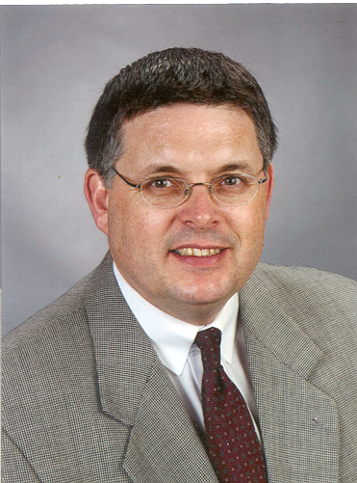

July 2-10

Speaker: Rev. Dr. Michael Benson
Bible Teacher: Dr. William Malas
Children’s Workers: Donny & Holly Woodbridge
Teen Leader: Dan Whitney

Children's Camp

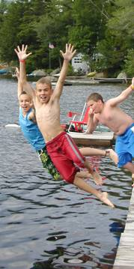
July 18-23

Grades 3-6
Director: Rick Smith
Speaker: Dan Couch, Pastor of the Saco Church of the Nazarene and Maine District Camp Director
Registration: 10 a.m. July 18
The week is filled with exciting challenges, great speakers and music, crafts, sports, archery, waterfront activities, lots of good food, with a setting in the middle of God’s beautiful creation.

Senior High Camp

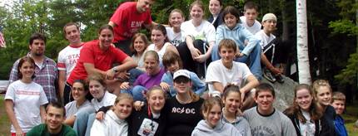

July 25-30

Grades 10-12
Director: Fran Wright
Registration: 10 a.m. July 25
Speaker: Rev. Jeff Barker

Register for all camps by downloading forms from
www.whcamp.org

So be careful how you live, not as fools but as those who are wise. Make the most of every opportunity for doing good in these evil days. Don’t act thoughtlessly, but try to understand what the Lord wants you to do.
~ Ephesians 5:15-17, NLT

New England District Calendar

JULY -- NMI Emphasis: International Ministry,
Bible Schools & Seminaries, and Prayer

14 Advisory Board Meeting
18-23 Combined Children’s Camp
25-30 Senior High Camp

AUGUST -- NMI Emphasis: LINKS & Prayer

1-6 Maine Camp
8-13 Junior High Camp
14-20 Music Camp
20 Children's Summer Fun Day

SEPTEMBER -- NMI Emphasis: Membership, Alabaster & Prayer
3-6 Family Retreat

Prayer Requests
James 5:13-14
We need to pray ...
- for Sally Zink and her cancer treatments and for comfort in these days of loss.
- Steve Pelechowicz - We need to be praying for him as he is not feeling well at this time.
- for our churches without pastors
- for all our public schools and students.
- for all of our churches!
- for our public officials both local and national.
- for unity in the Body of Jesus Christ!
- that the Anointing of the Holy Spirit fall fresh in every service!
- for the sick and hurting in all of our churches and homes!
- for new people to be won for Jesus Christ!
- that God will use each of us everyday as an instrument of HIS Love to others!
- that HE will increase our Faith in HIM!
Praises!!!
David Wooster is recovering at home, he’s doing well and working with a physical therapist!
- We praise HIM for waking us up this morning!
- We praise HIM for sending HIS SON!
- We praise HIM for providing for our tables and shelter for our comfort.
- We praise HIM for HIS love.
- We praise HIM for sending the HOLY SPIRIT!

Let our prayer be:
“Thy Will Be Done!”

New England District Church of the Nazarene
162 Old Colony Avenue
PO Box 690513, Quincy, MA 02170-0513
Phone: 617-786-9496, Fax: 617-786-9574
E-mail: nedoffice@cs.com

Jossie Owens, District Superintendent
Gary W. Jones, Assistant District Superintendent

